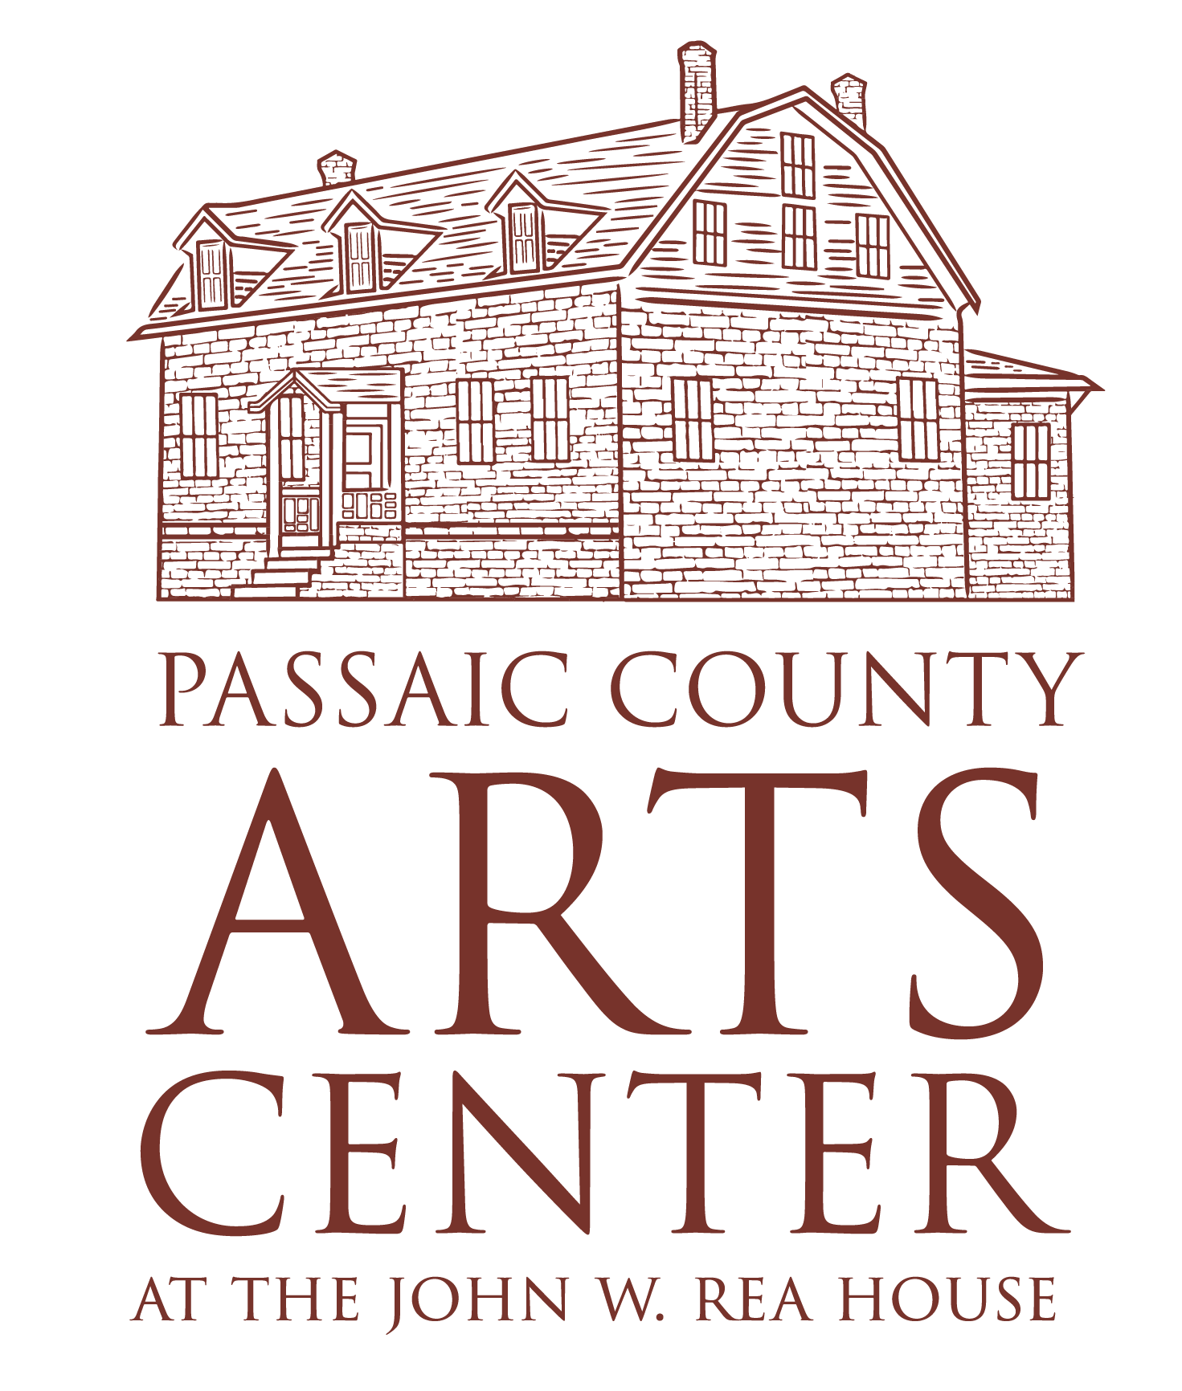 Un-Building a Justic Facility:

Ethics in Architecture
Exhibition Checklist | September 16, 2026 – December 4, 2026

Overview of Architecture that Hurts and Architecture that Heals Assemblages
By Erin Newton

Architecture is never neutral. Architecture shapes human experience. Spaces can comfort or isolate, restore or exhaust, protect or exclude. The built environment influences not only how we move through the world, but how we feel, heal, remember, connect, and belong. This study began by investigating the questions: Can architecture hurt, and can architecture heal? As students investigated this question, they discovered that the answer is complicated. Their work revealed a series of ethical paradoxes. Buildings may not cause suffering on their own, yet they often become places where suffering is experienced. Also, architecture may not independently heal, yet it can create conditions that support dignity, resilience, recovery, and hope. Students examined different architecture styles and functions that accommodate experiences of hurting and healing. You know these spaces as detention centers, shelters, medical offices, and community centers. They investigated how architecture/design/space can influence how we create these environments to function as sites that continue harm or encourage healing. They also studied how these environments can actively support restoration of one’s humanity across physical, psychological and social dimensions.

Ultimately, the "Un-Building Justice" and "Holding Hurting/Holding Healing" components of this installation address ethics and Architecture. The demolition of the Passaic County Jail was our case-study for reframing architecture as an ethical practice that invited students to reimagine our carceral system. Every design decision carries consequences for those who inhabit our buildings and cities. This exhibition invites visitors to consider architecture not only as an act of making places, but as a responsibility to one another, to our communities, and to our shared humanity.
Architecture That Hurts
Failing Correction Hurts, 2026
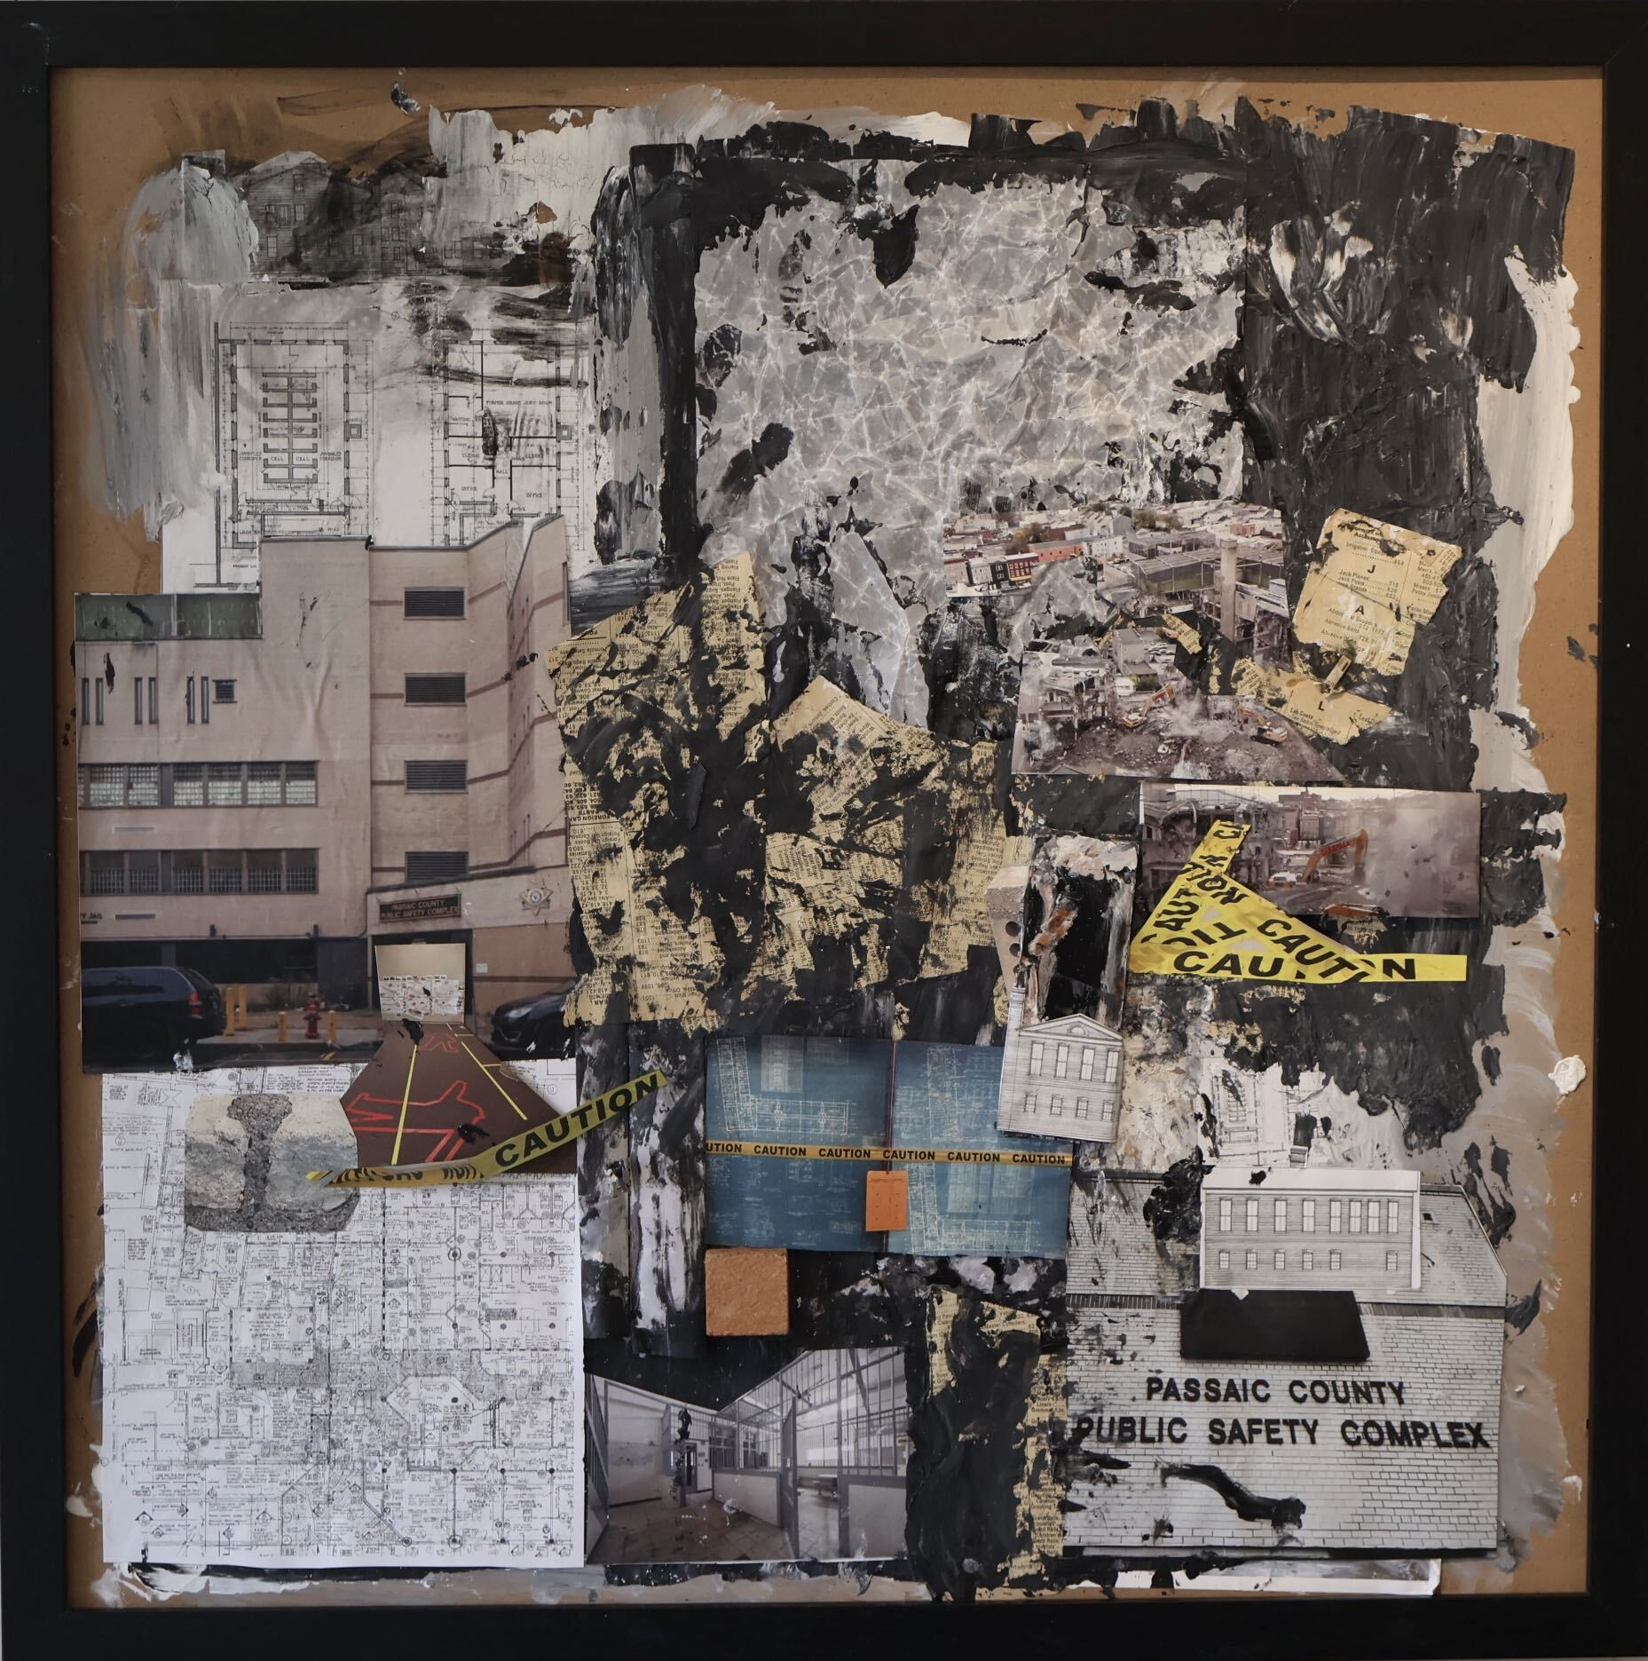
Erin Newton
Framed, 25.5 in x 25.5 in
Mixed Media

Shelter Among the Streets, 2026
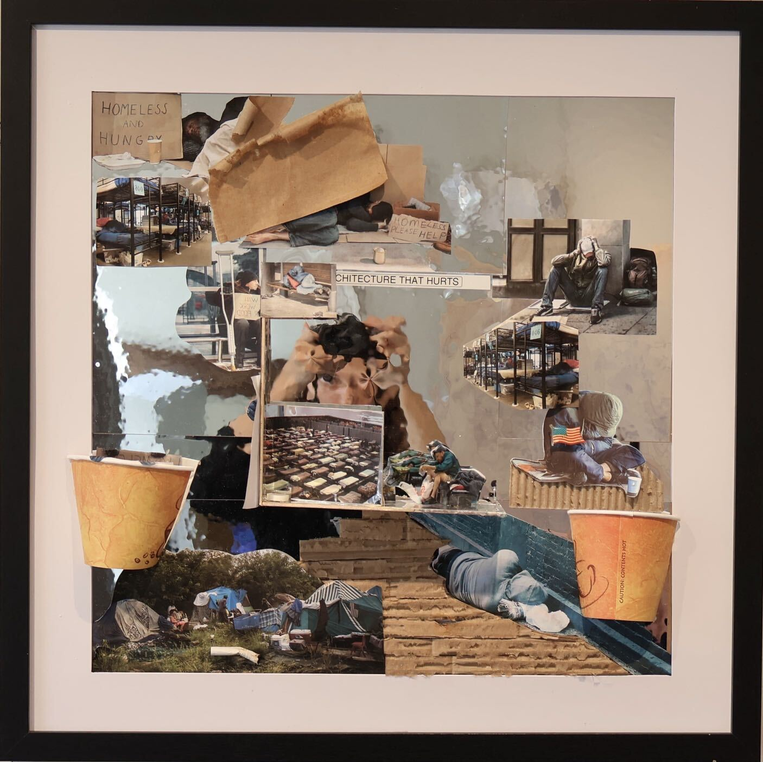
Cristian Caiza
Framed, 25.5 in x 25.5 in
Mixed Media

Ruins of Rehabilitation, 2026
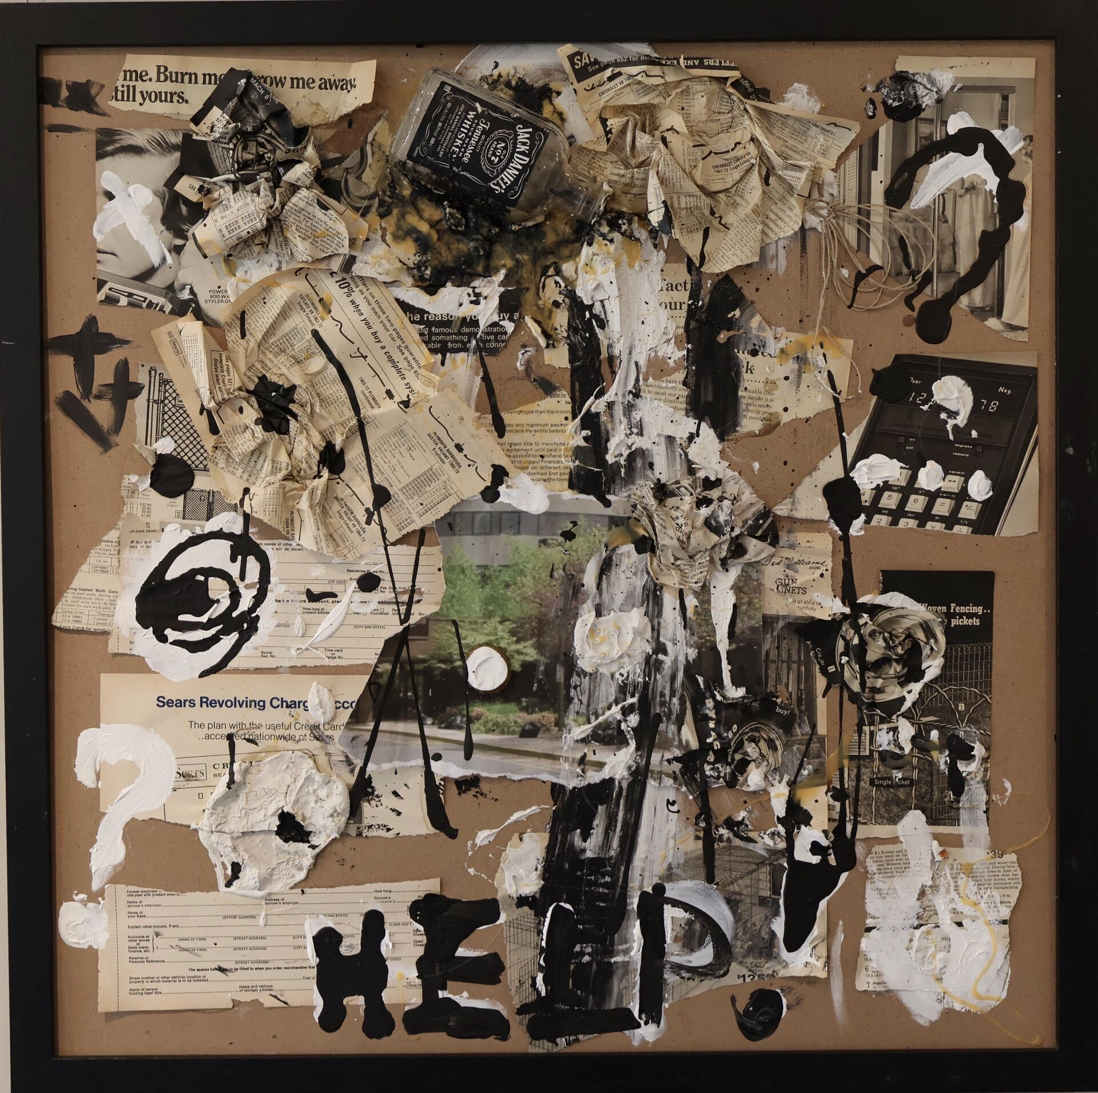
Cameron Zotti
Framed, 25.5 in x 25.5 in
Mixed Media

Red, White, and Detained 2026

Jaylene Rodriguez
Framed, 25.5 in x 25.5 in
Mixed Media

Behind the Institutional Wall, 2026
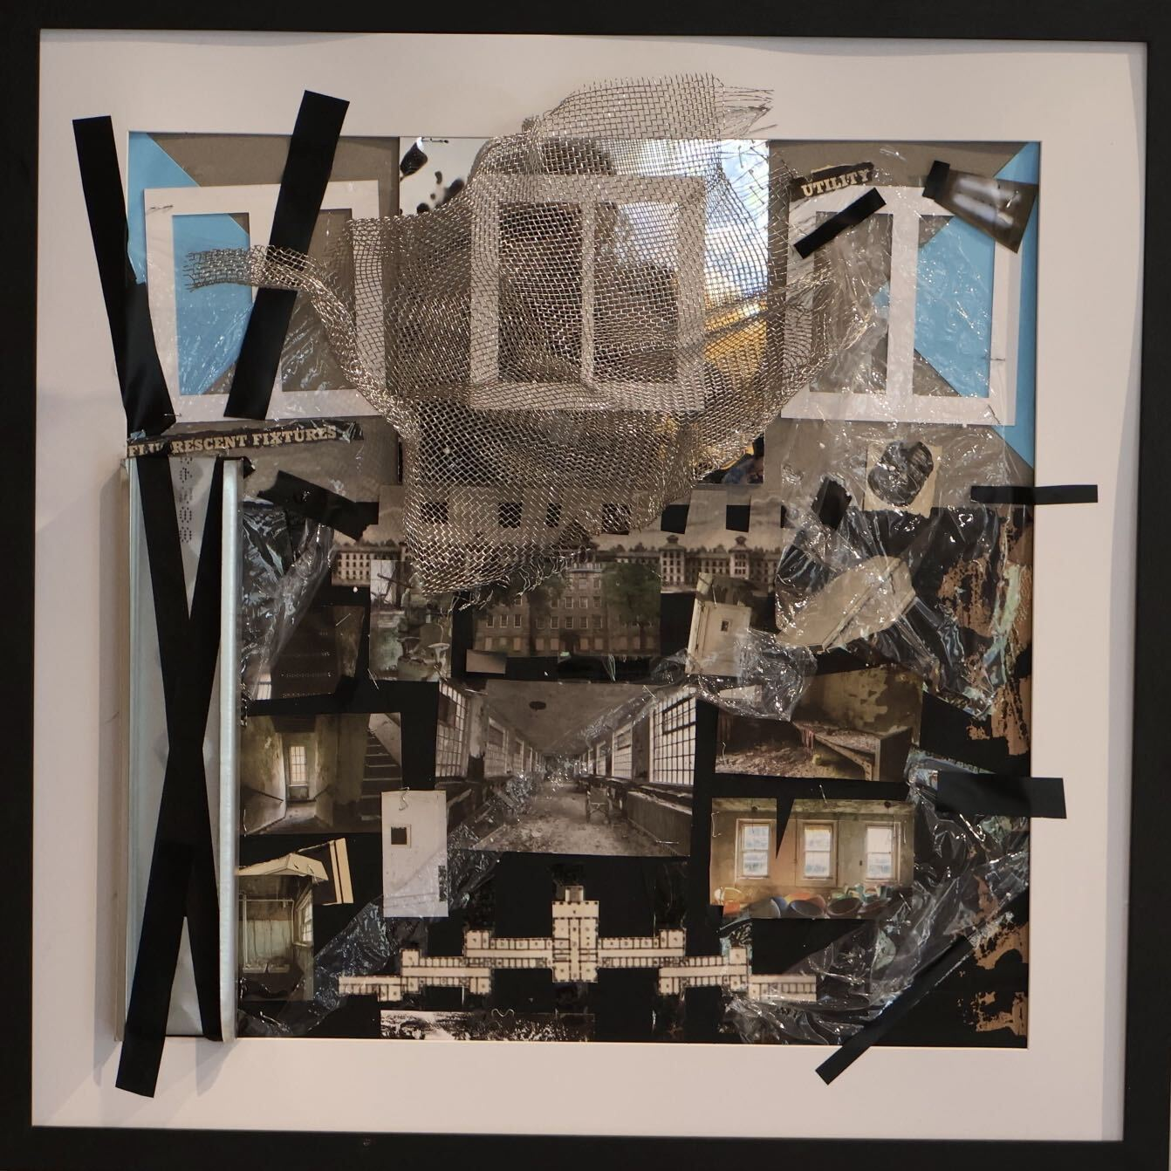
Vannah Kaye Ravara
Framed, 25.5 in x 25.5 in
Mixed Media

Hospital of Wounds, 2026
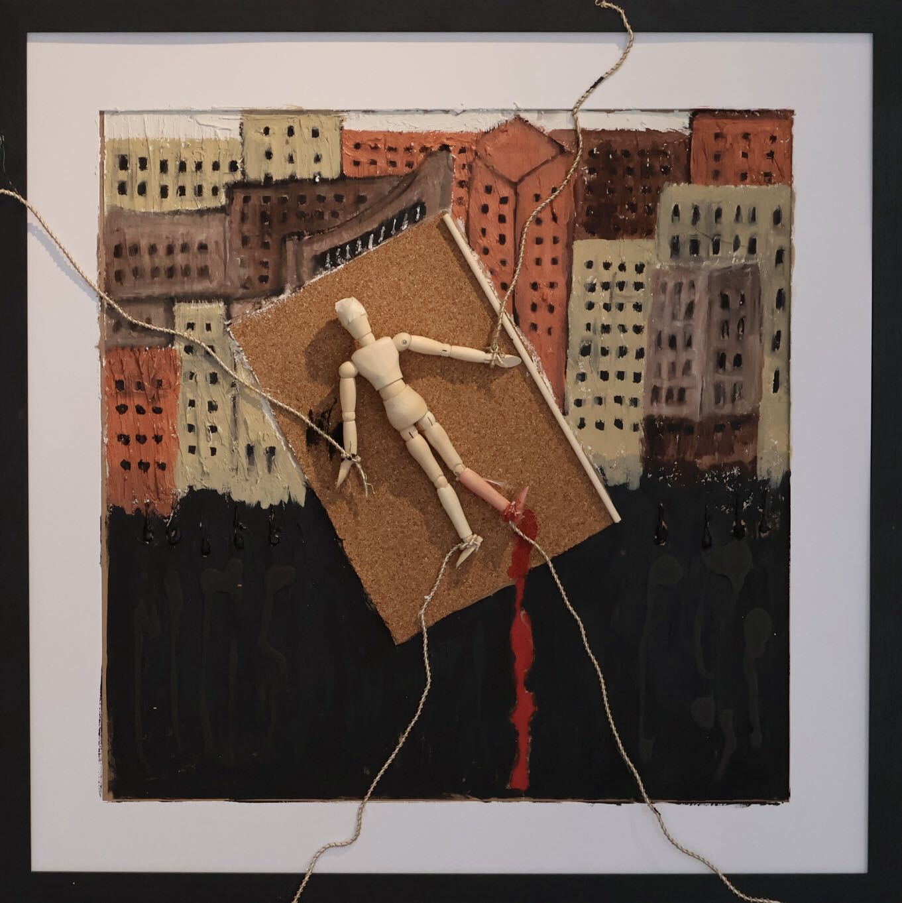
Vanessa Vallejo
Framed, 25.5 in x 25.5 in
Mixed Media

Architecture That Heals
Space to Reform Heals, 2026
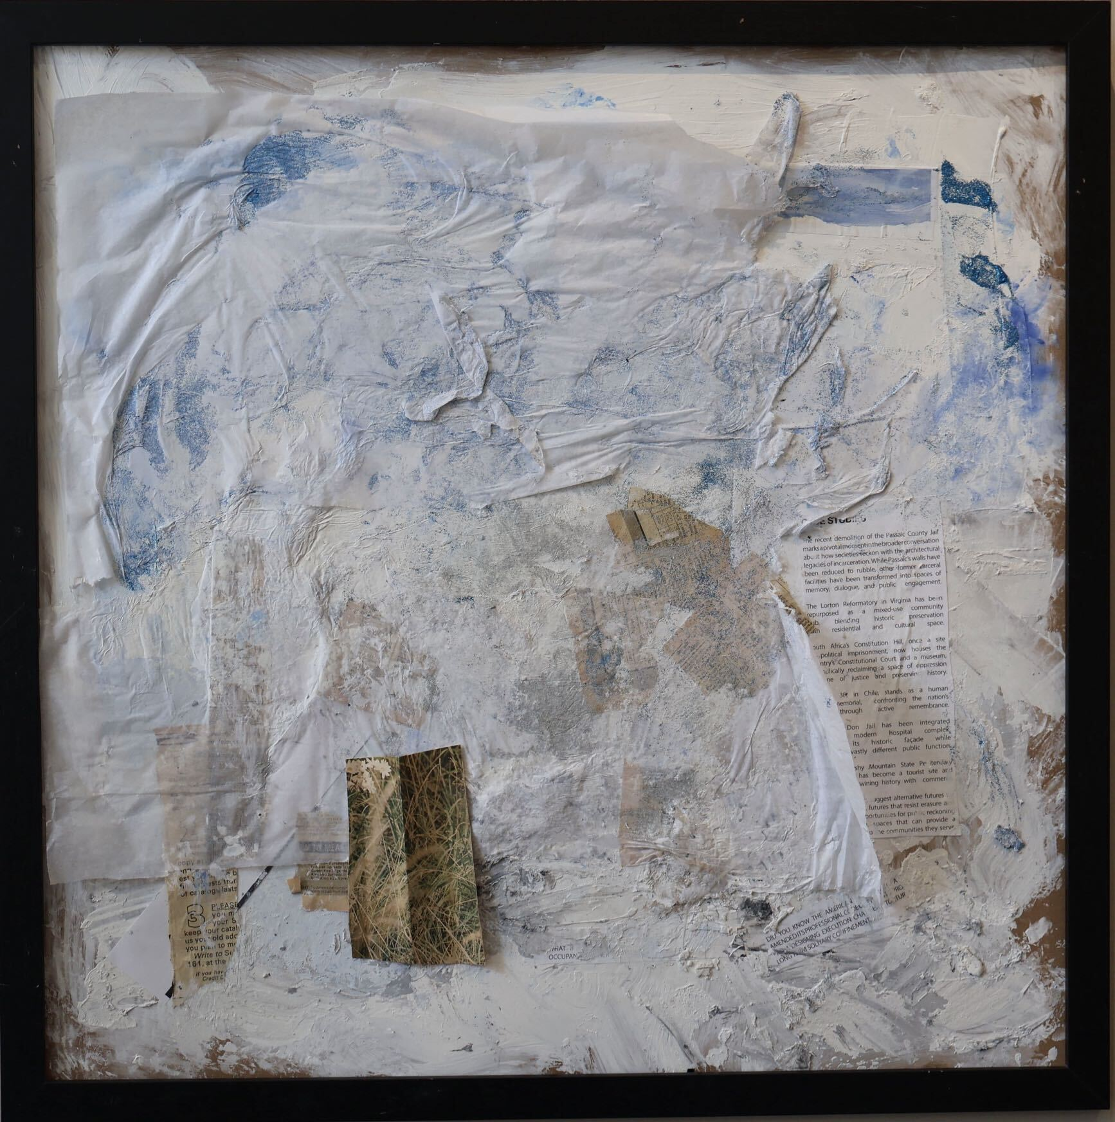
Erin Newton
Framed, 25.5 in x 25.5 in
Mixed Media

Shelter Where Home Begins, 2026
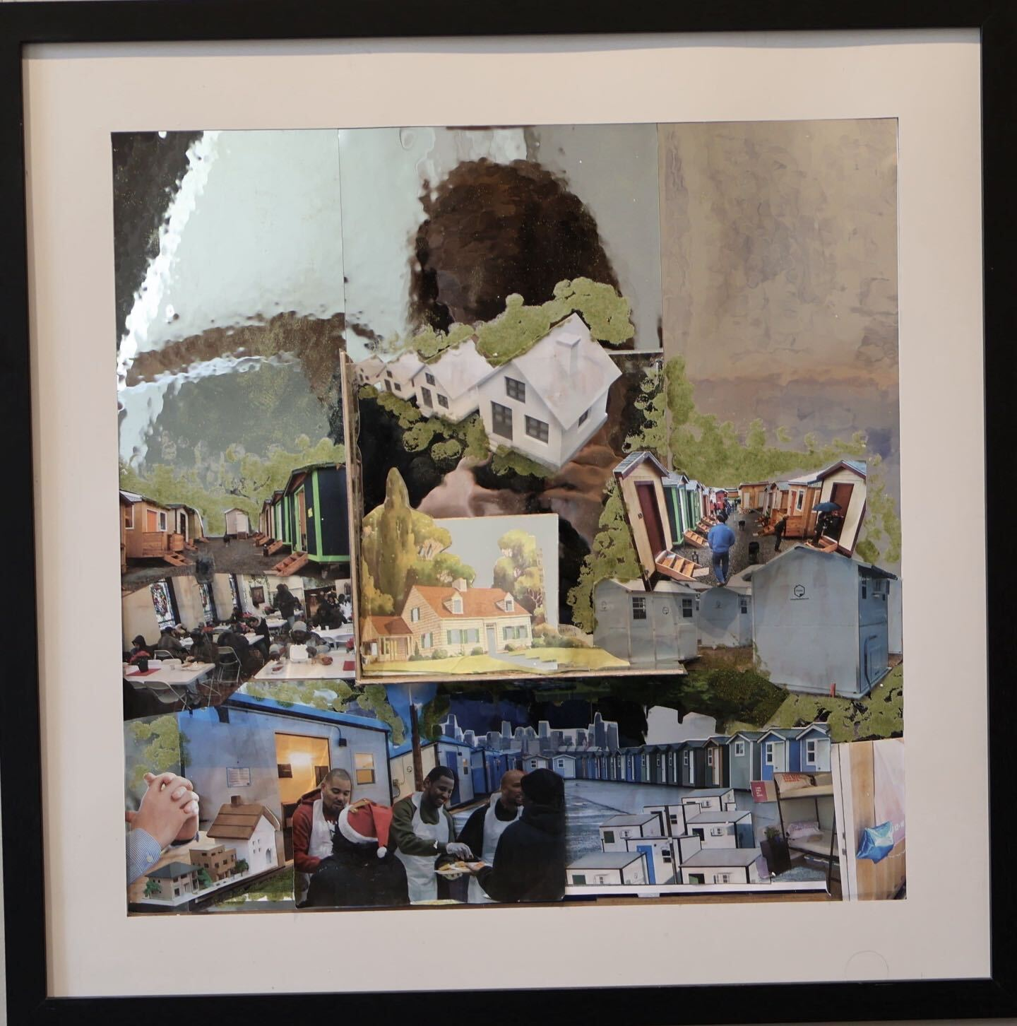
Cristian Ciaza
Framed, 25.5 in x 25.5 in
Mixed Media

Promise of Rehabilitation, 2026

Cameron Zotti
Framed, 25.5 in x 25.5 in
Mixed Media

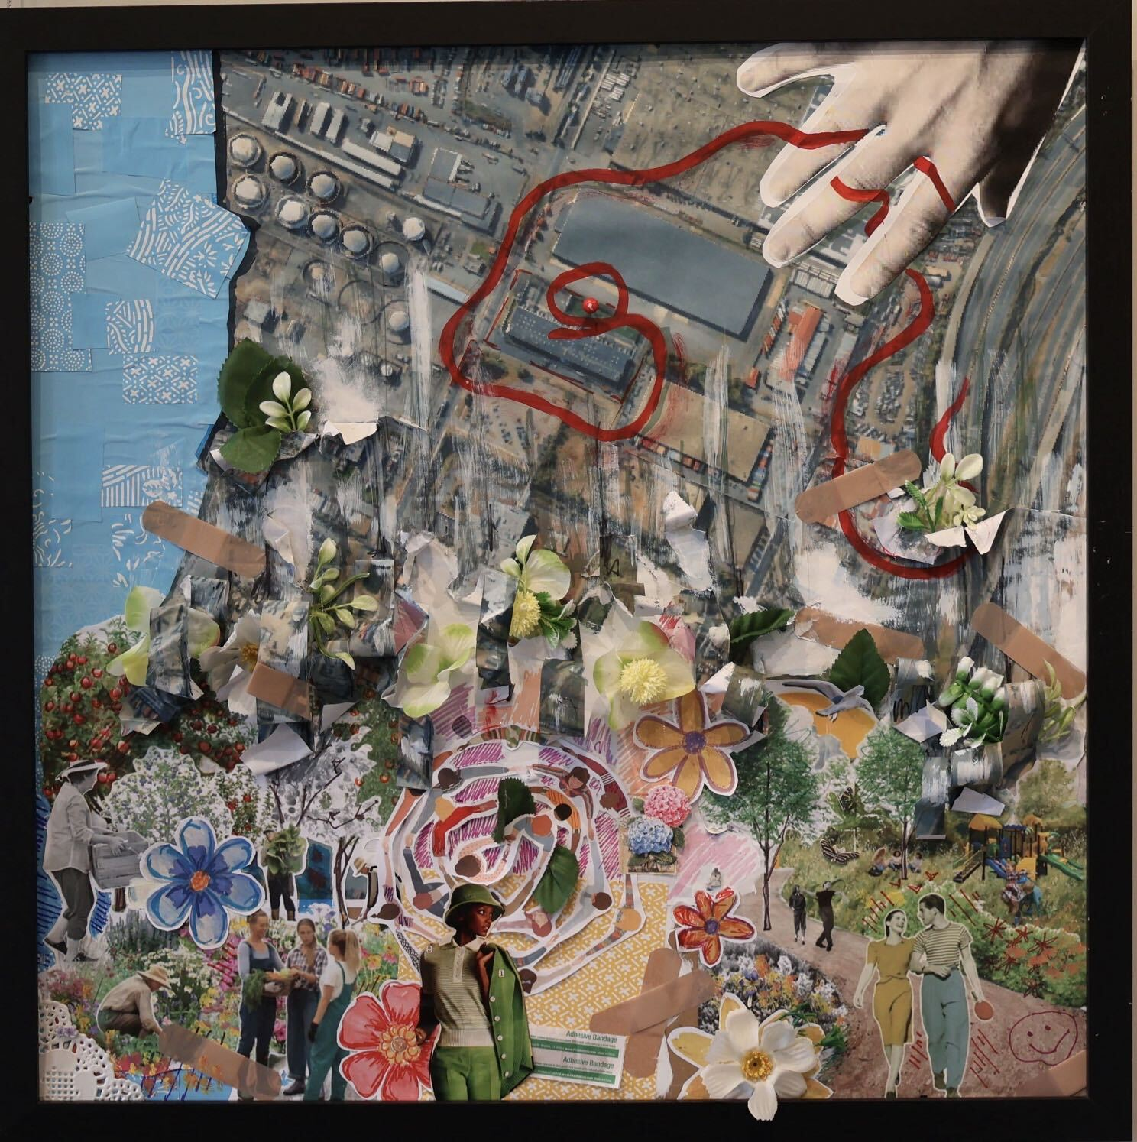
Shredding the Border, 2026

Jaylene Rodriguez
Framed, 25.5 in x 25.5 in
Mixed Media

Beyond the Institutional Wall, 2026
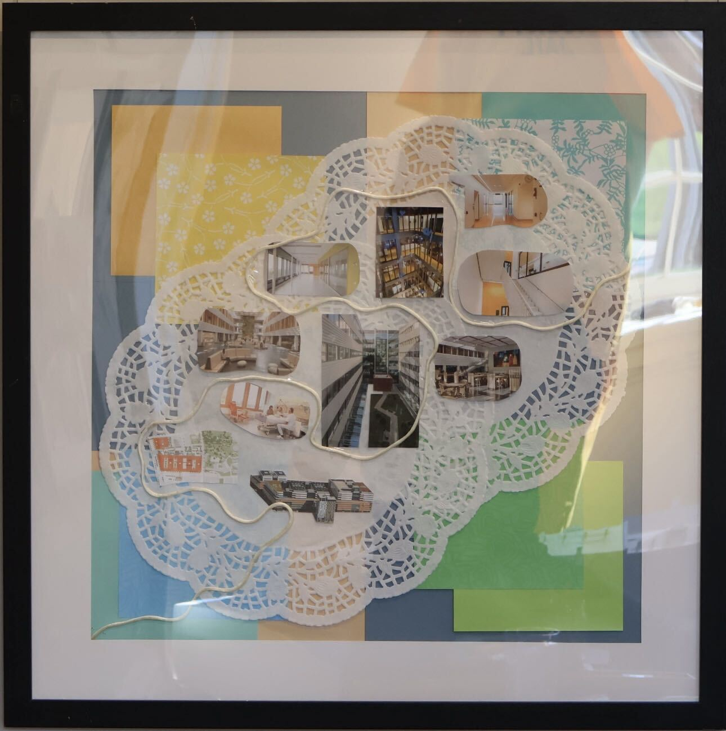
Vannah Kaye Ravara
Framed, 25.5 in x 25.5 in
Mixed Media

Hospital of Renewal, 2026
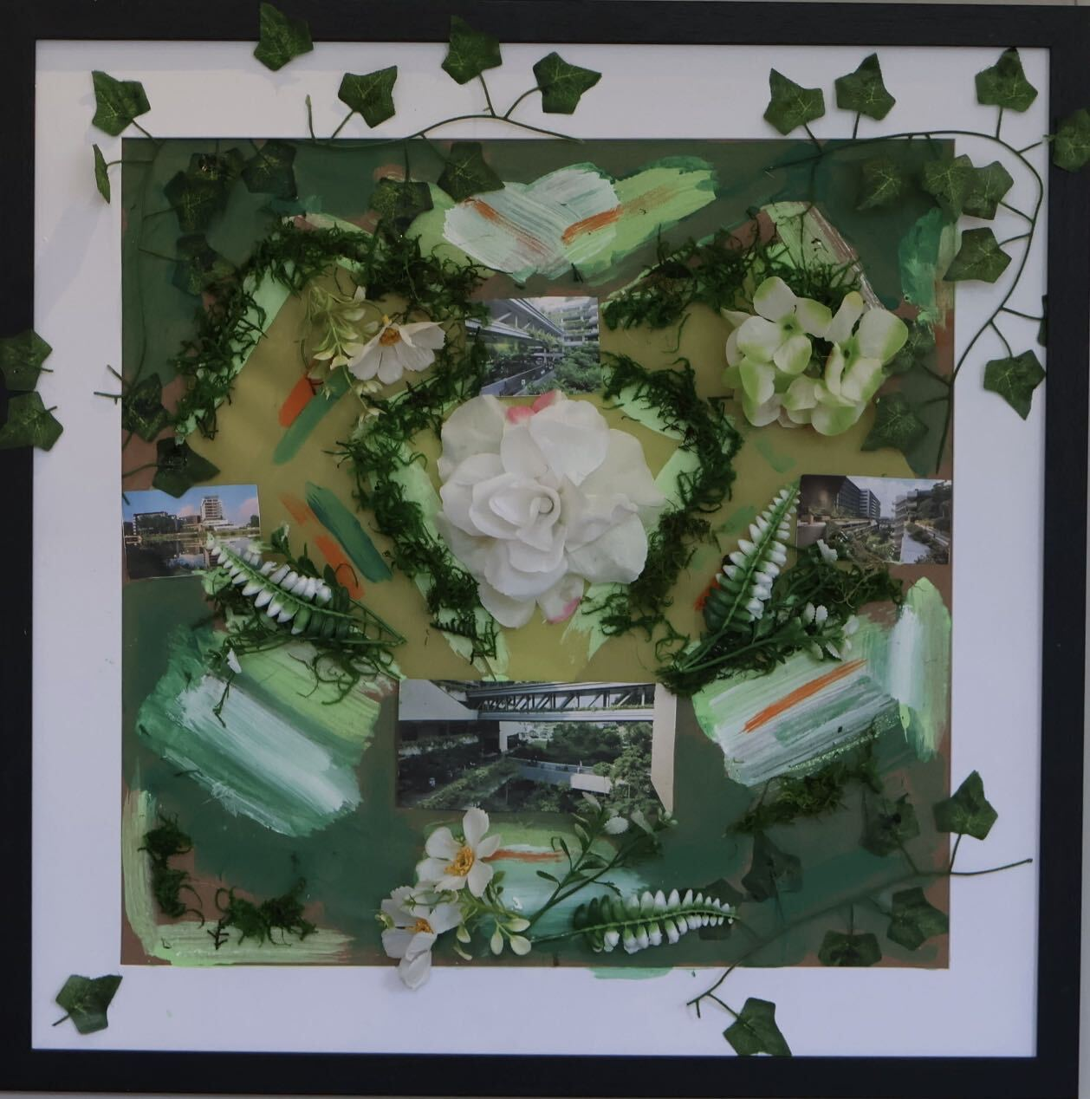

Framed, 25.5 in x 25.5 in
Mixed Media

Forensic Wall, 2025

2025 Master of Architecture Students,
School of Public Architecture at Kean University
Mixed Media

Remnants from Demolished Passaic
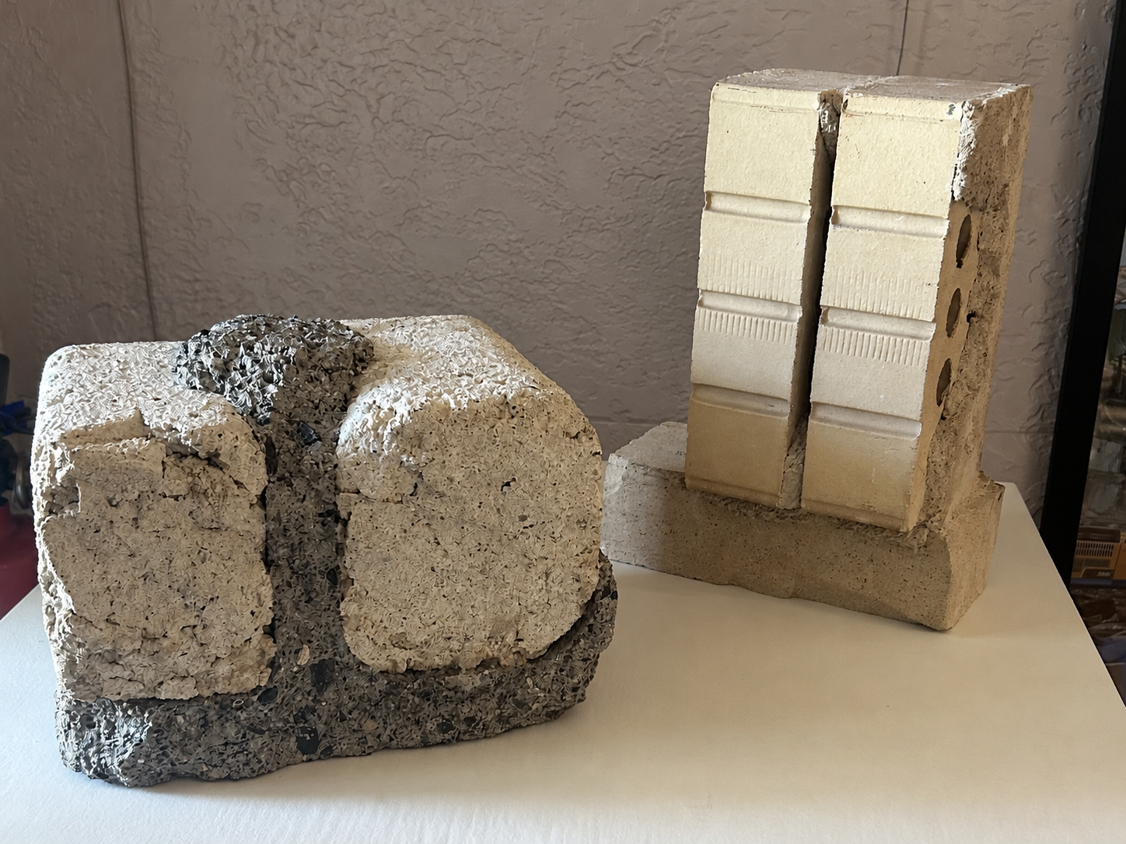
County Jail, 1980’s

Christopher Cabarcas
Concrete

Model of Historic
Passaic County Jail, 2026
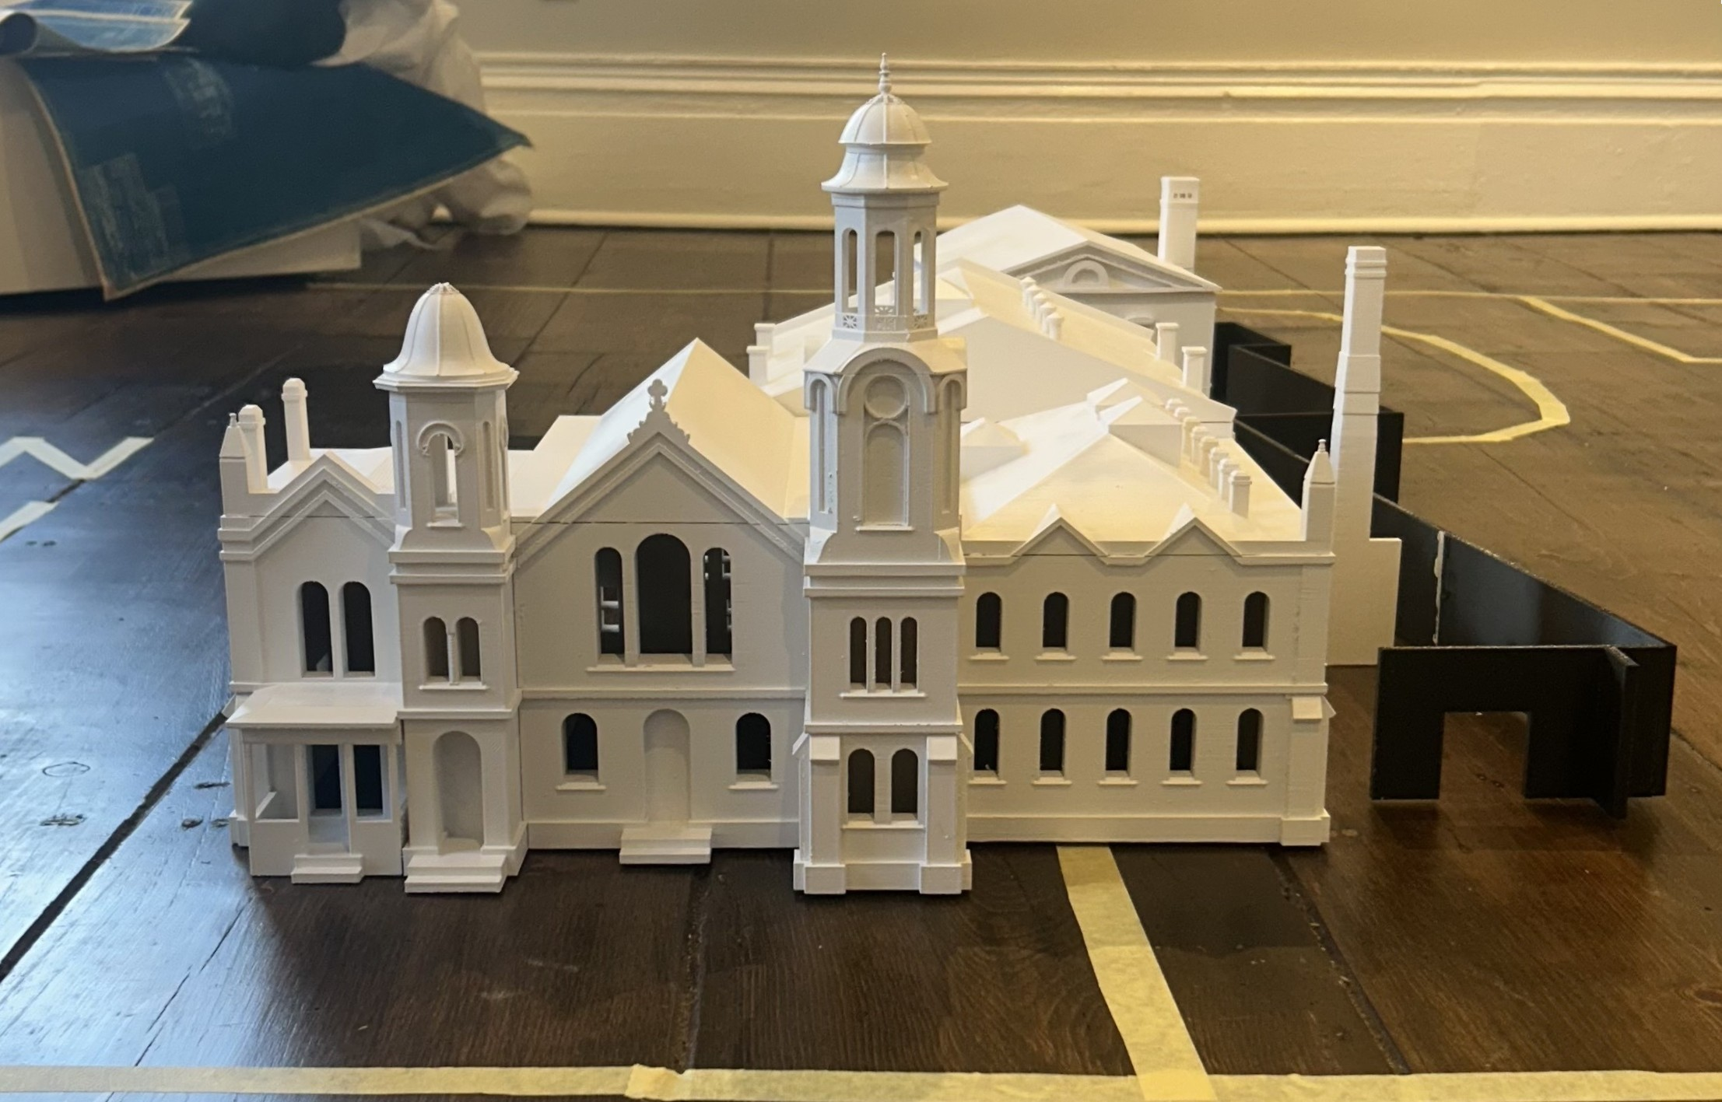
Camille Sherrod, Professor
Max Rogowski, Student
Dimensions
Composite Filaments

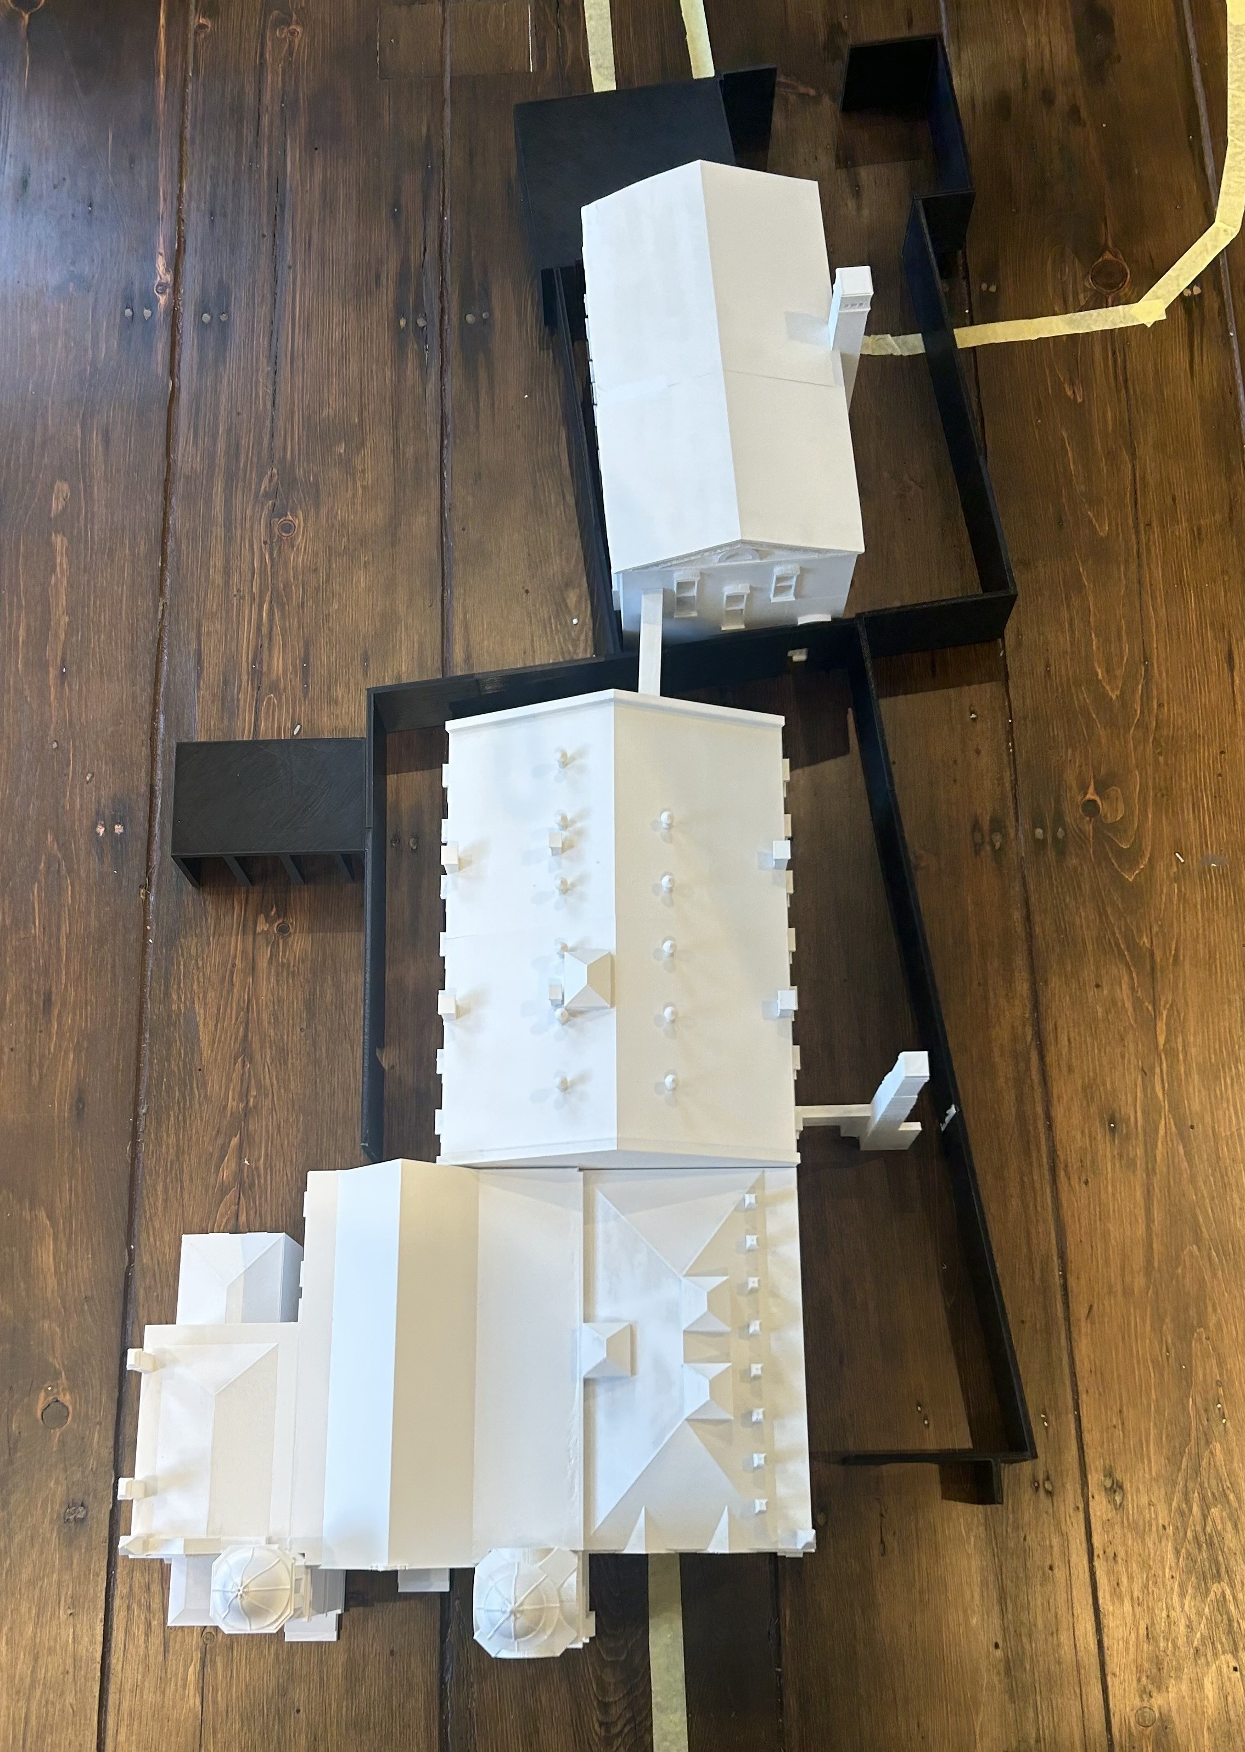

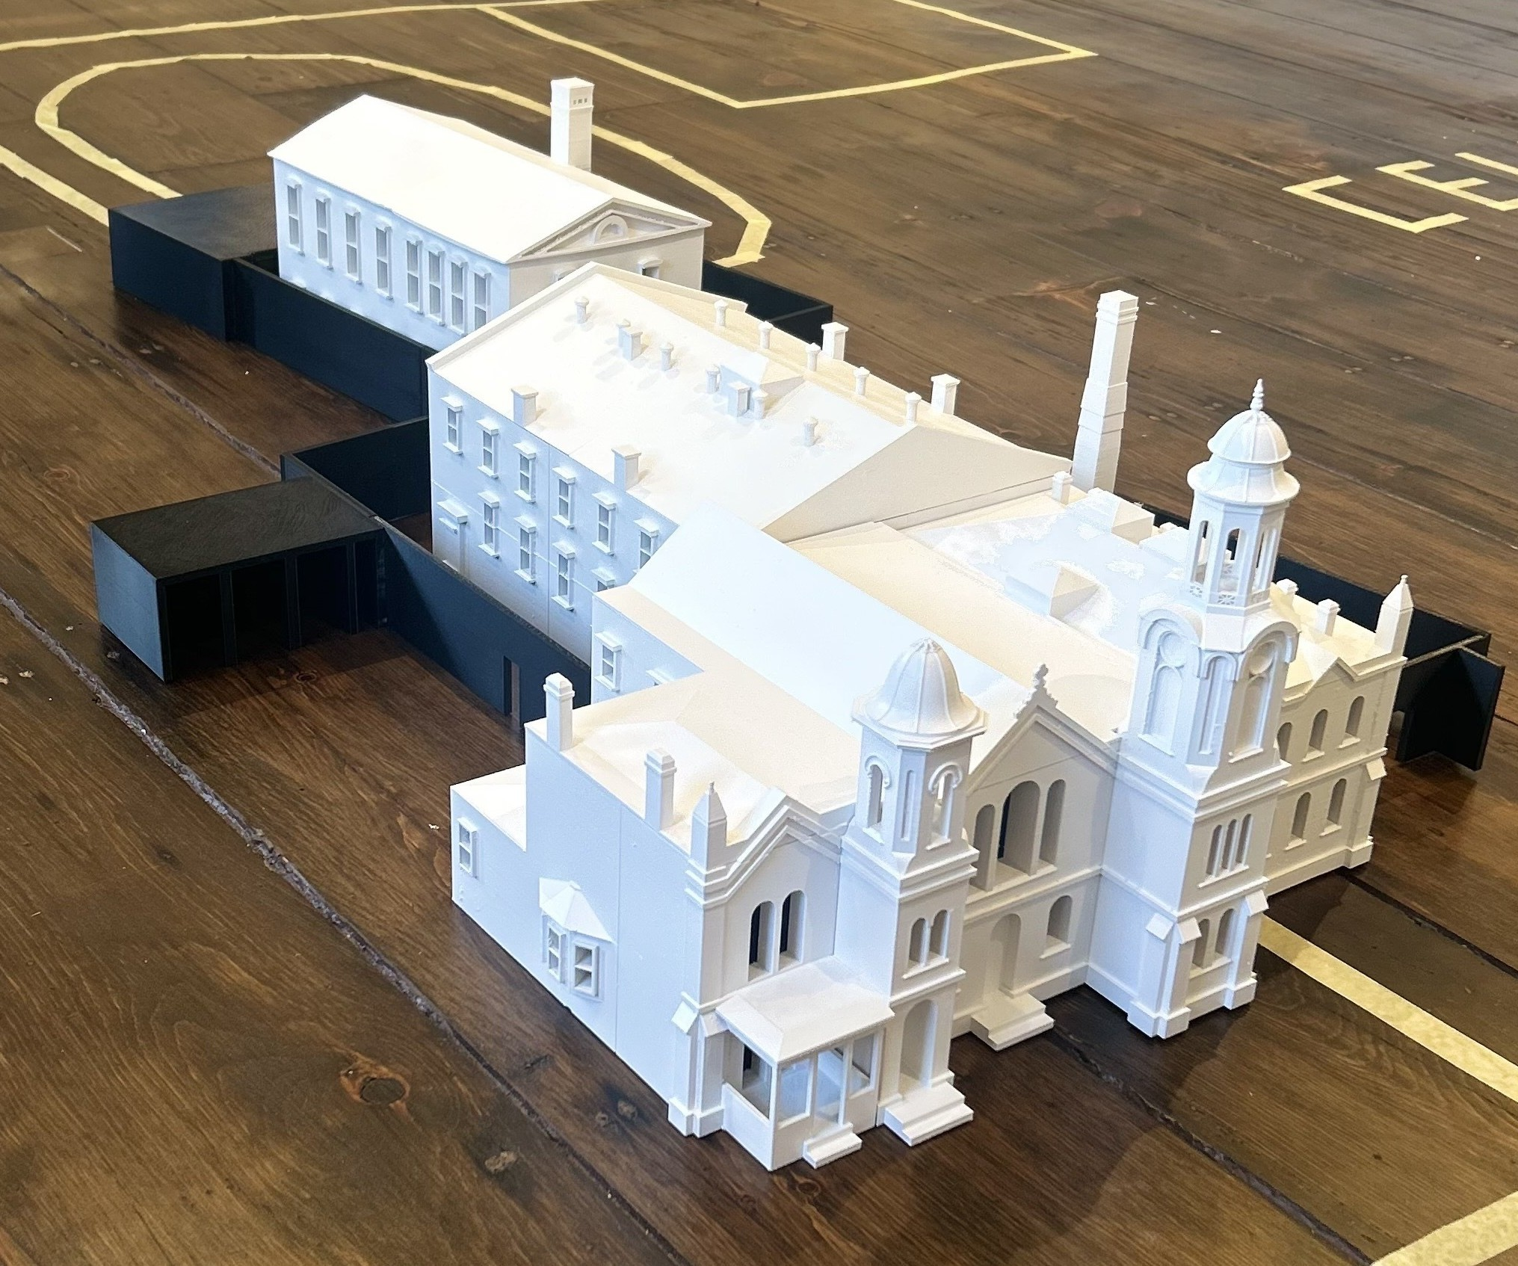

Instructor Biographies

Camille Sherrod, Professor
Camille Sherrod, RA is a full-time professor at Kean University's School of Public Architecture, with a wealth of diverse international academic experience. Holding a Bachelor of Architecture from Southern Polytechnic State University in the US and a Master of Architecture and Urbanism from the Architectural Association in the UK, Camille brings a unique perspective to her faculty role. She is also committed to empowering minority students and women in the field by fostering an inclusive environment for all. Camille has previously worked in architectural practices both within the US and internationally since 2009 including Zaha Hadid Architects in London, UK, and Jack Gordon Architects in New York. Tall projects she has previously been involved in include the Youth Olympic Center Towers, Nanjing, China (topped out 2014).
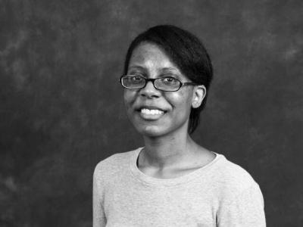
Areas of Expertise

- Technical Construction Documentation
- Student Mentoring
- 3D & BIM Modeling
- Construction Administration
- Presentation Graphics
- Competition Design
- Professional Practice

Architect’s Statement
Celebrating diversity in our profession not only in composition, but in the way architecture is practiced and through its priorities is critical. Each architect brings something uniquely valuable to the profession and my role, one I gladly accept as part of the .03%**, is to make the content of my instruction relevant to each student's life and individual perspective. I see the value in an approach which takes into account the rigorous development of one's individual agenda and design intuition, risk-taking, diverse forms of expression and a strong foundation. **.03%, percentage of black female architects in the US in 2018.

Erin Sharp-Newton, Professor

Erin Sharp Newton is a recognized advocate in the fields of architecture, design, healthcare and mental health. Her work emphasizes how environments can positively influence mental health dn well beings, creating a continuum of care and filing systemic gaps in community infrastructure needs. As a passionate professional she serves as the Director of the Centre for Urban Design and Mental Health, an internation think-tank focused on building mental health in tour cities. She has been a Fellow since 2016. She also served 2024 President of AIA CNJ (the American Institute of Architect, Central NJ0 and has been serving as the Chair of the Department of Health and Human Services Local Advisory Committee on Drugs and Alcohol, and former Vice President of an Outpatient Drug Awareness Program, she focuses on designing solutions from grassroots to global levels, for which she received the NJ Bizz 50 Best Women in Business Award.
Architect’s Statement
Erin focuses on curating innovative solutions to transform projects that prioritize wellbeing, and respect research and practice. She has been featured in venues such as the Royal College of Physicians in London, Biennales, and Triennales, at conferences and publications. She is active in mentorship as a juror and critic for academic institutions Through her outreach initiatives, including collaboration with the Children’s Ciris Treatment center in Philadelphia, Erin underscores her dedication to uplifting humanity and communities. In addition to advocacy, Erin’s experience in market leadership and business development enables her to drive impactful projects through vision and commitment She inspires compassion and courage through highlighting the profound impact of the built environment on overall lived experience.
Participating Students
2025 Master of Architecture Students, School of Public Architecture at Kean University
Professors: Erin Sharp-Newton, Camille Sherrod, Cheng Chen
Forensic Wall
Brianna Ayzen
Nada F. Alzoubi
Brianna Ayzen
Jennifer Banzon
Abigail Boussios
Christopher Cabarcas
José Calixto
Daisy Chacho
Angela Cumella
Cristopher Ferreira
Patrick Gergich
George Gwaldis
Alec Hehir
Geoffrey Infosino
Giovanny Martinez Cano
John Montoya
Erny Salazar
Wakeemah Sawyer
Varrianna Siryon
John Stalteri
Ludny Thelisma
Kailey Viera
Rasheed Warren

2026 Master of Architecture Students, School of Public Architecture at Kean University
Professor: Erin Sharp-Newton
Assemblages : Architecture Hurting/Architecture Healing
Cristian Caiza
Vannah Kaye Ravara
Jaylene Rodriguez
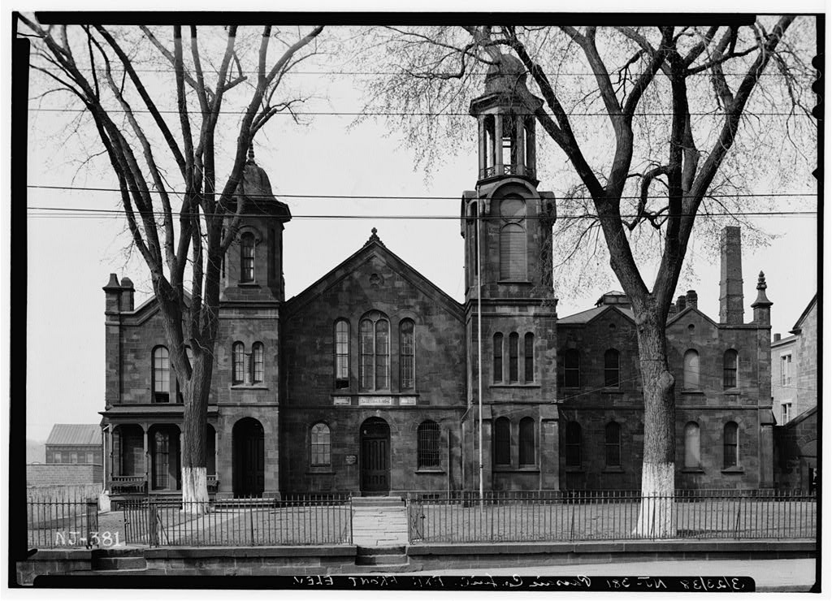
Vanessa Vallejo
Cameron Zotti

2026 Master of Architecture Students,
School of Public Architecture at Kean University
Professor: Camille Sherrod
Physical Model of 1839 Passaic County Jail
Christopher Cabarcas

