 The Life and Art of Don Kommit

Exhibition Checklist | September 16, 2026 – December 4, 2026

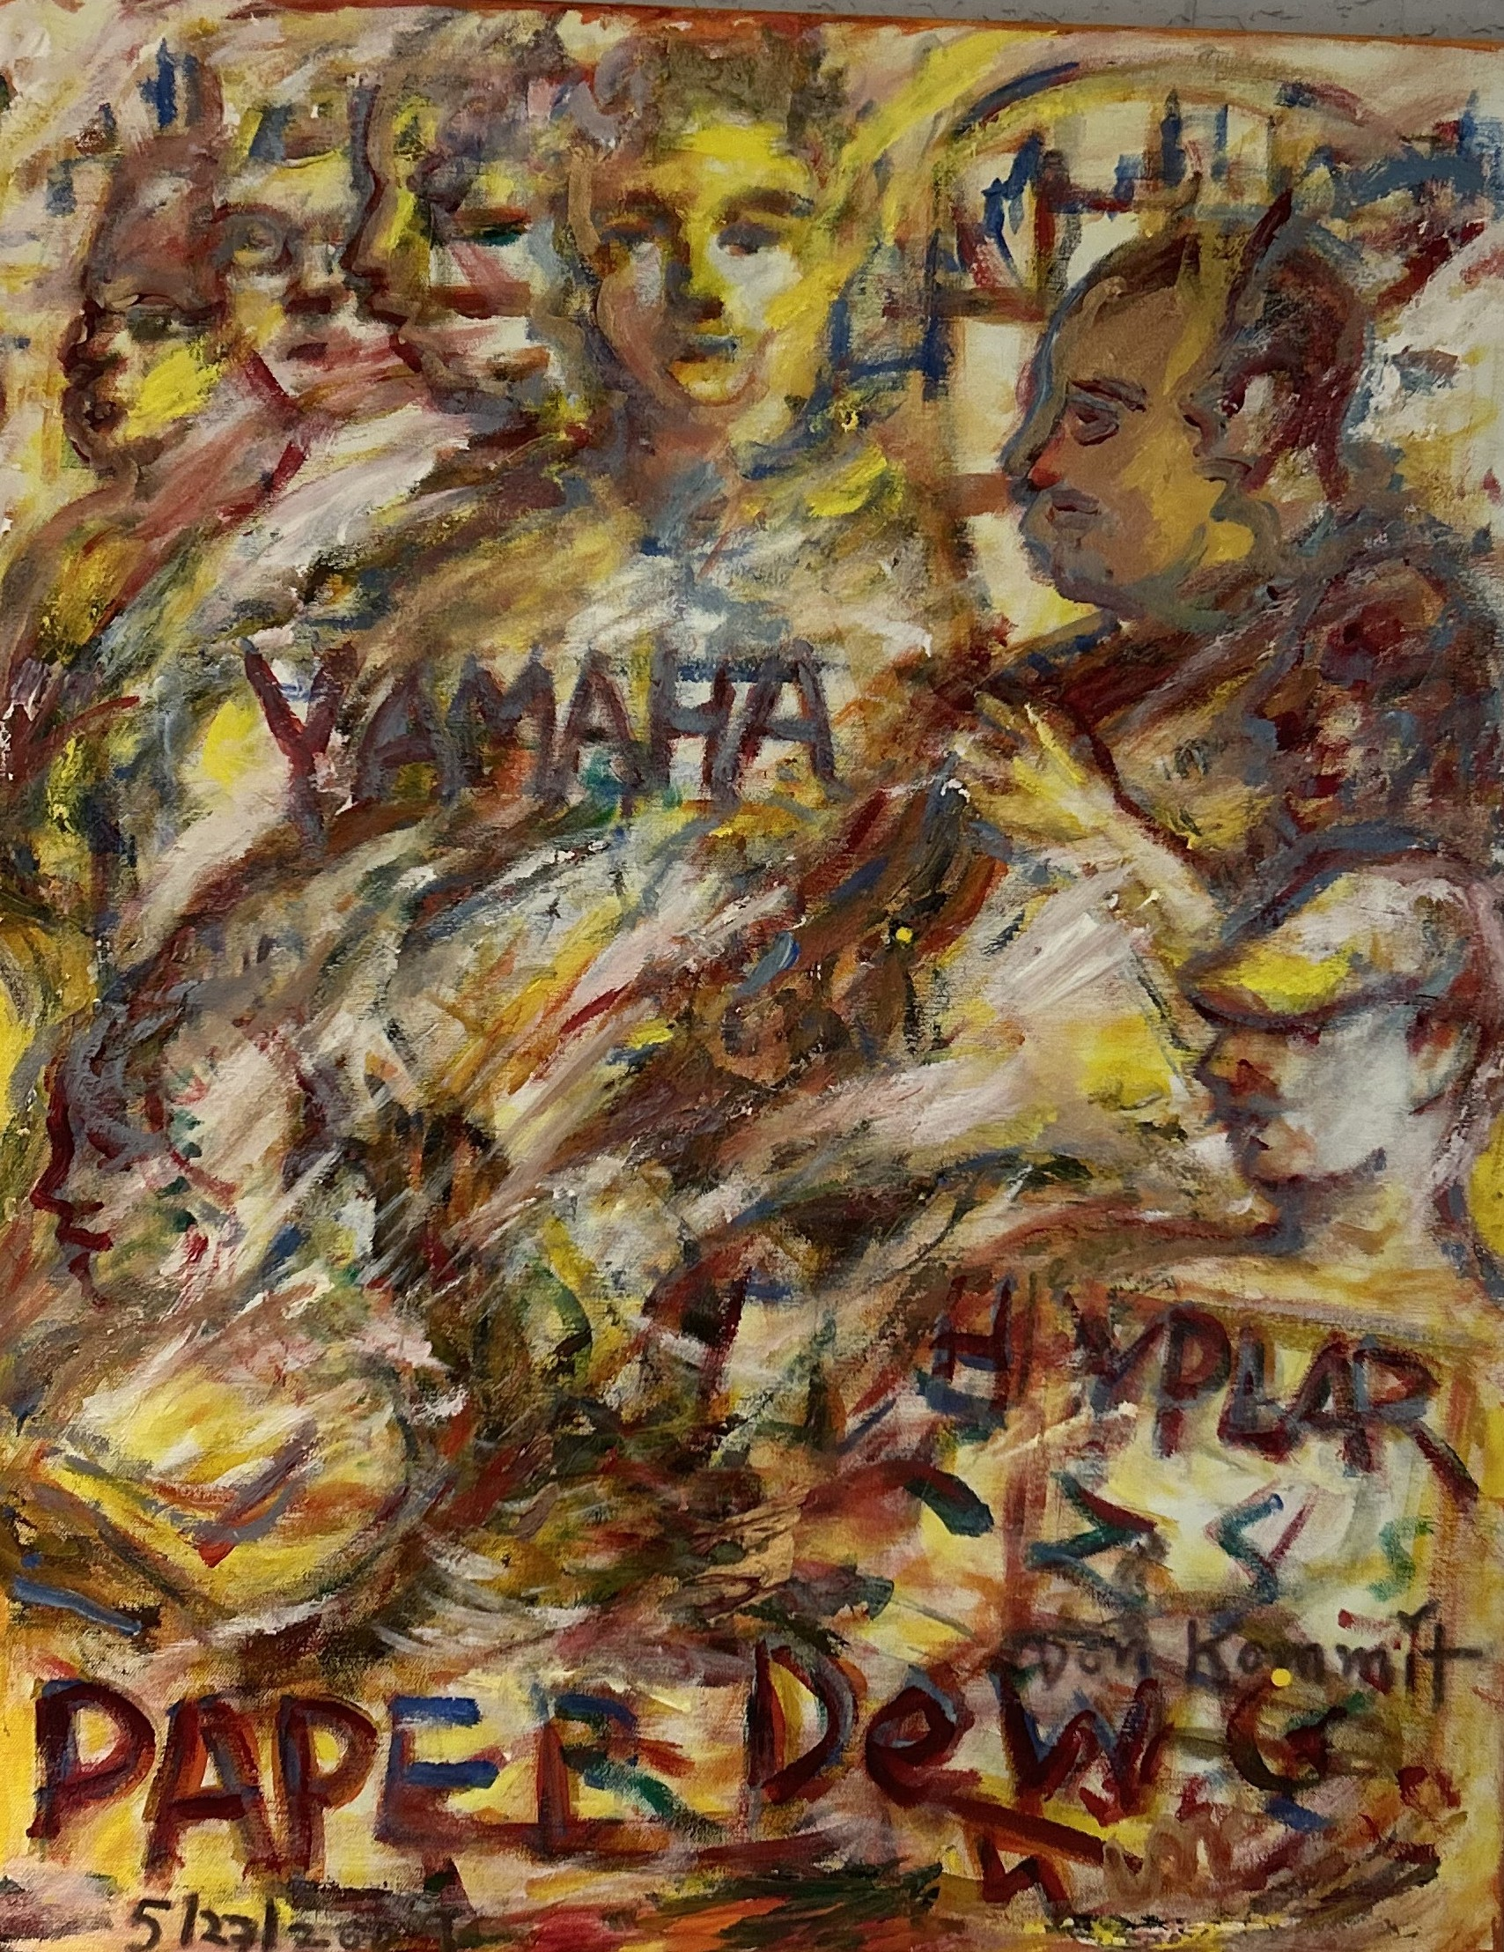
Yamaha – Paper DeVole, 2009
Don Kommit
30 in x 24 in
Acrylic on Heavy Watercolor Paper

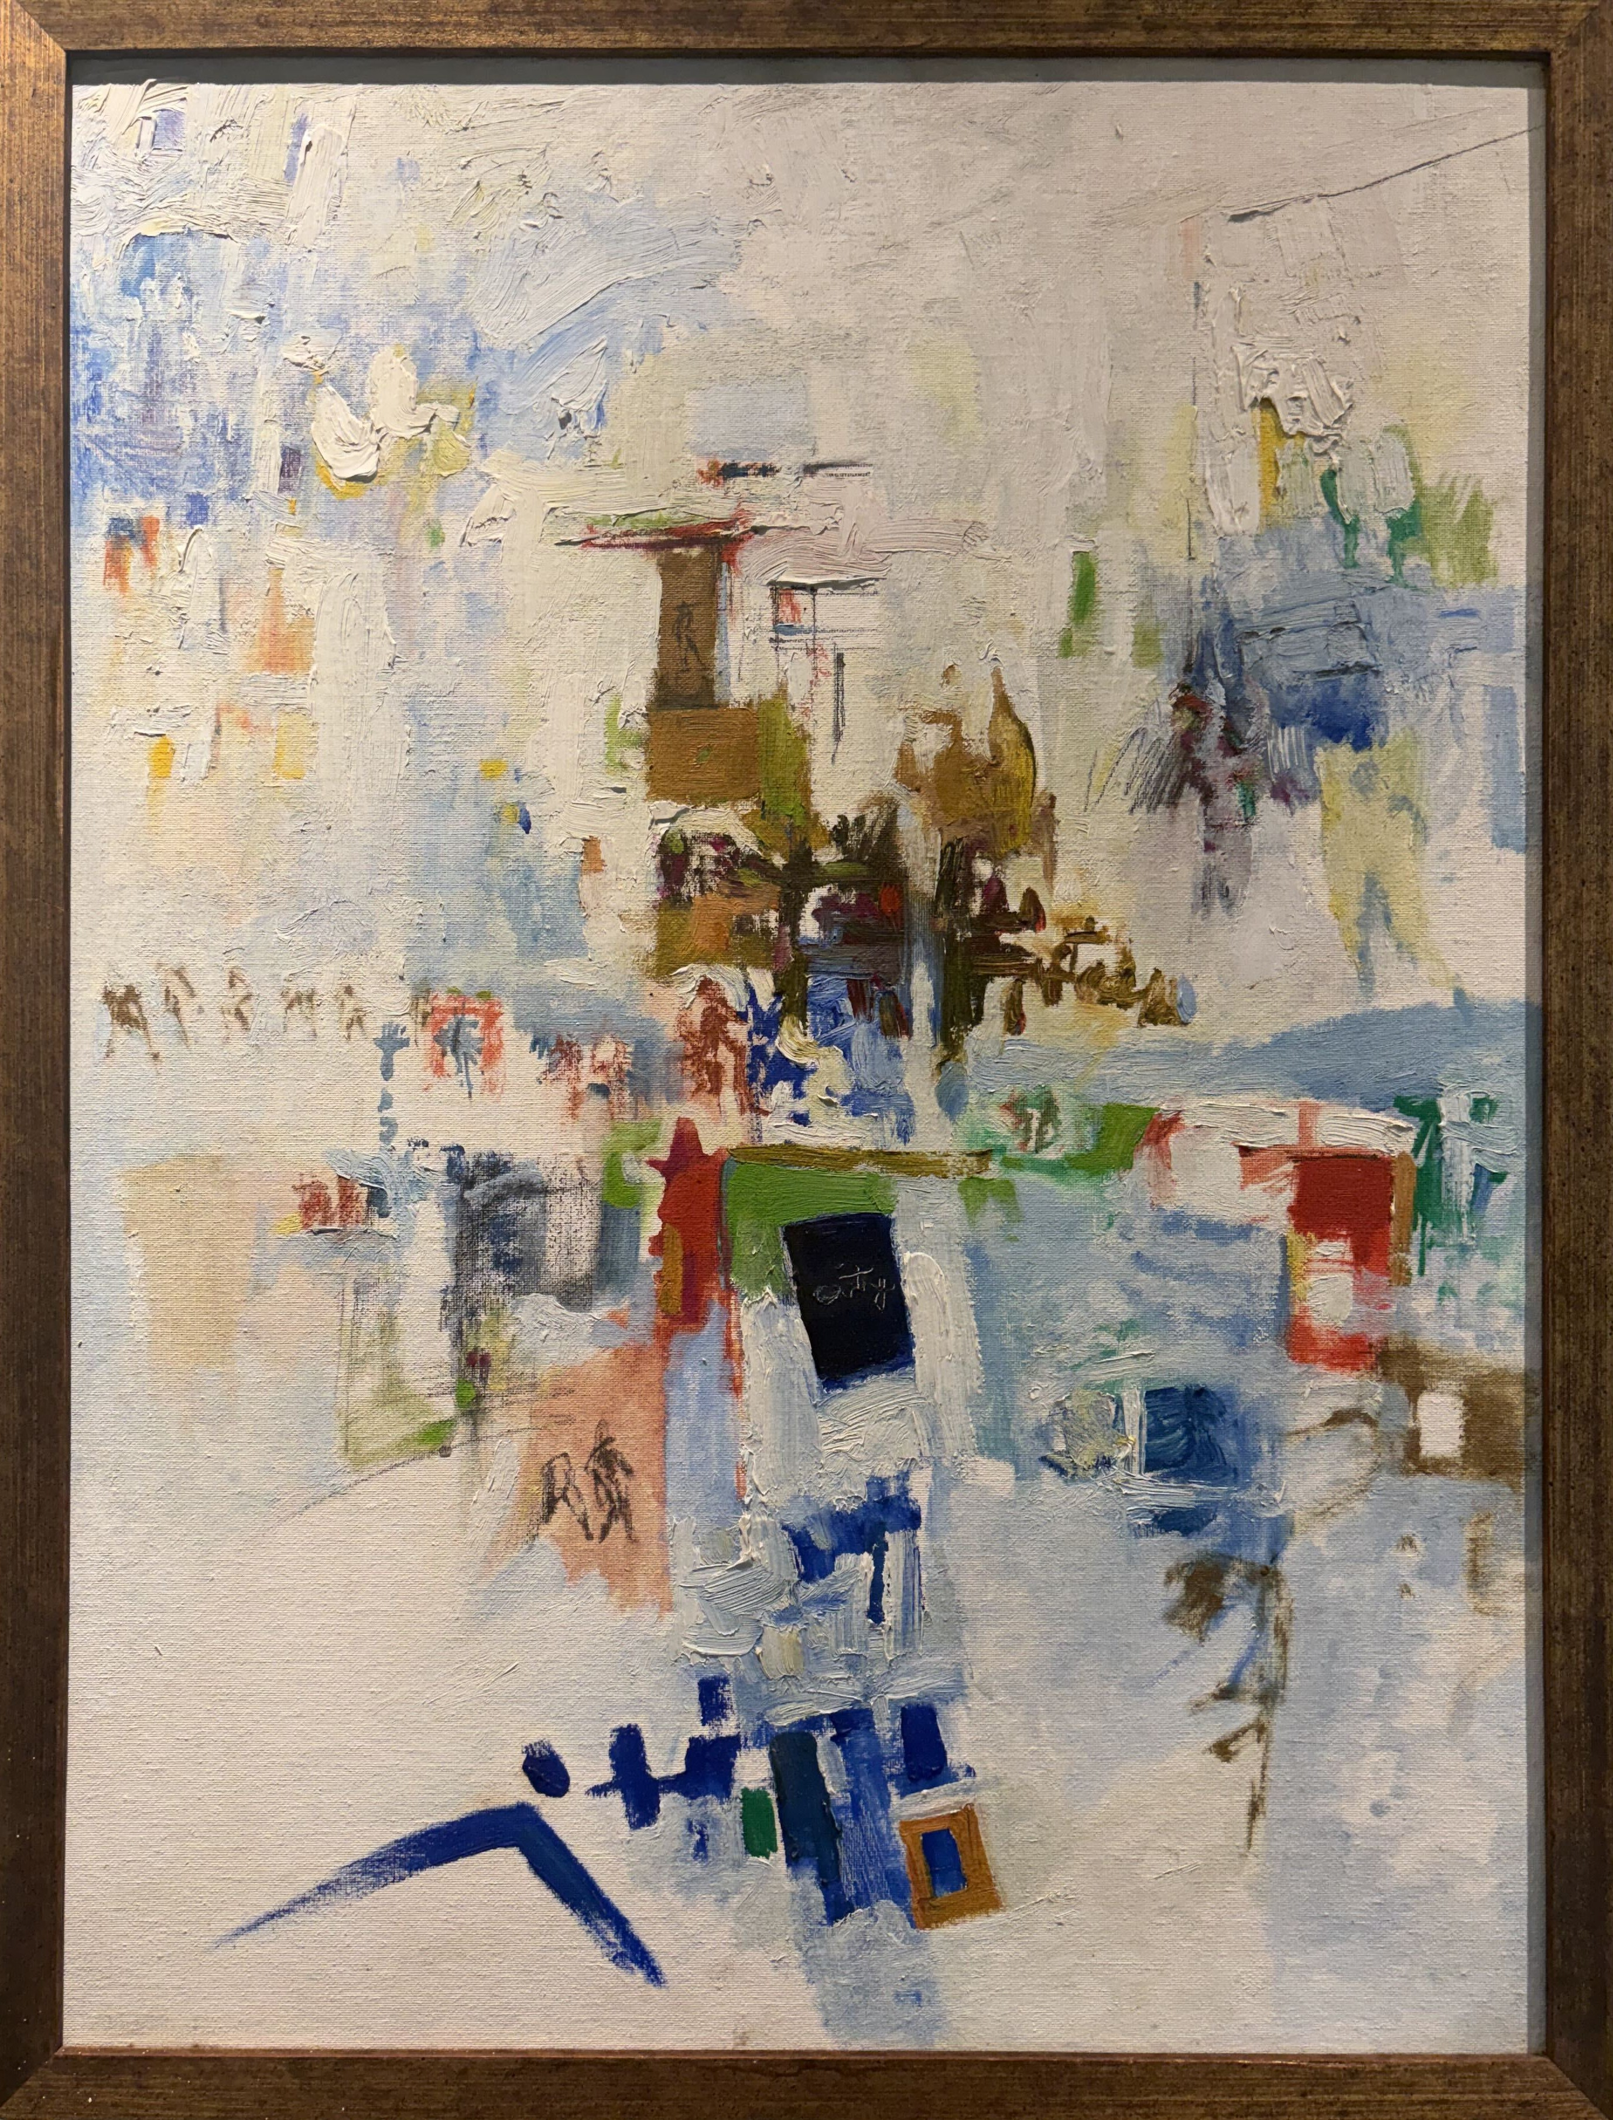
White Abstraction, 1990

Don Kommit
24 in x 18 in
Acrylic on Canvas Board

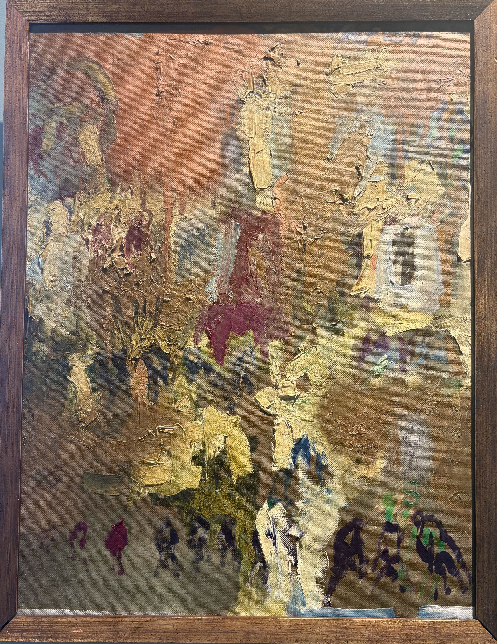
Bronze Abstraction, 1970

Don Kommit
18 in x 24 in
Oil on Canvas Board

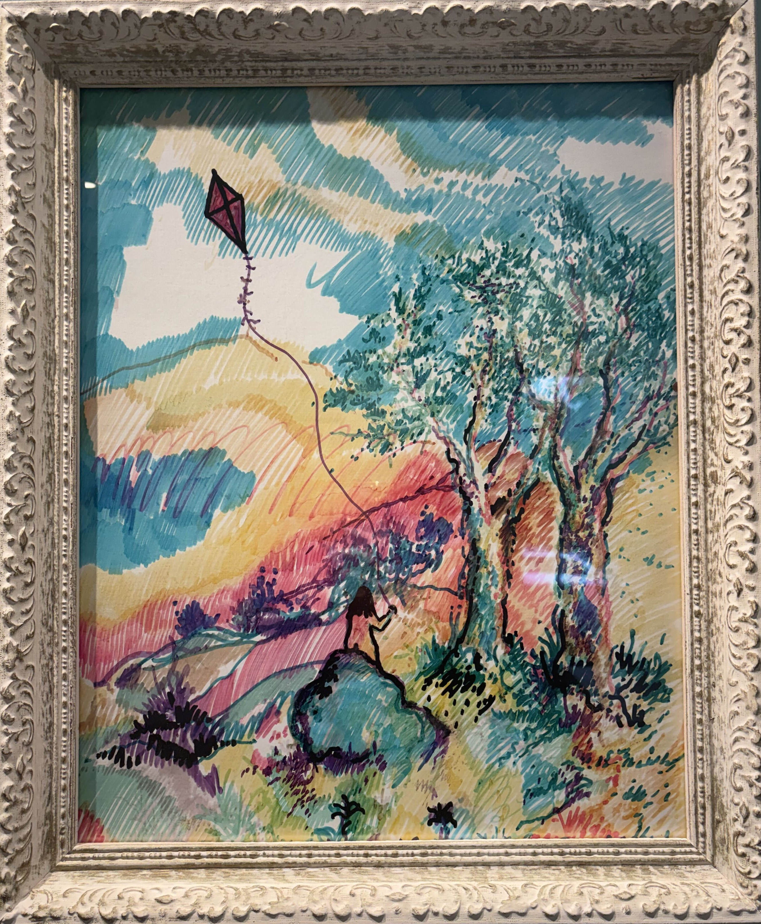
Kite Day, 1970

Don Kommit
16 in x 20 in
Oil on Canvas Board

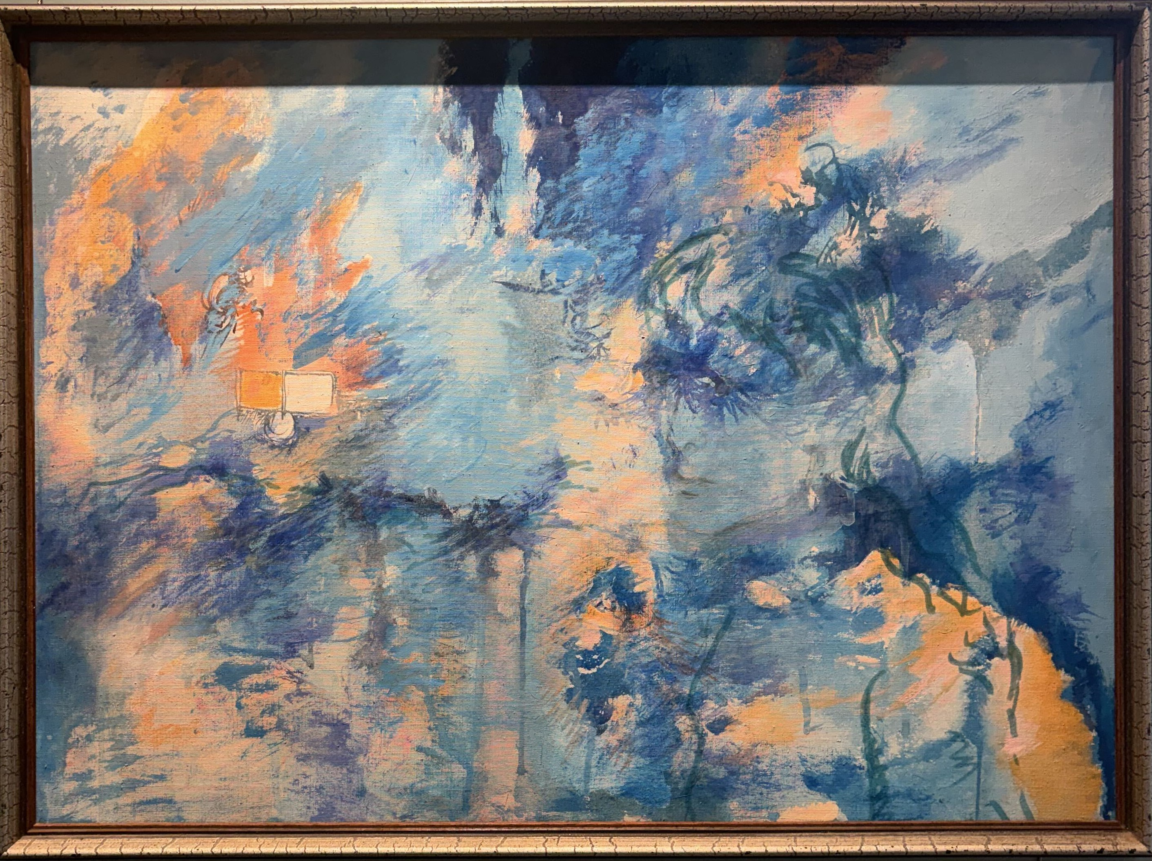
Blue Abstraction, 1980

Don Kommit
26 in x 19 in
Acrylic on Canvas

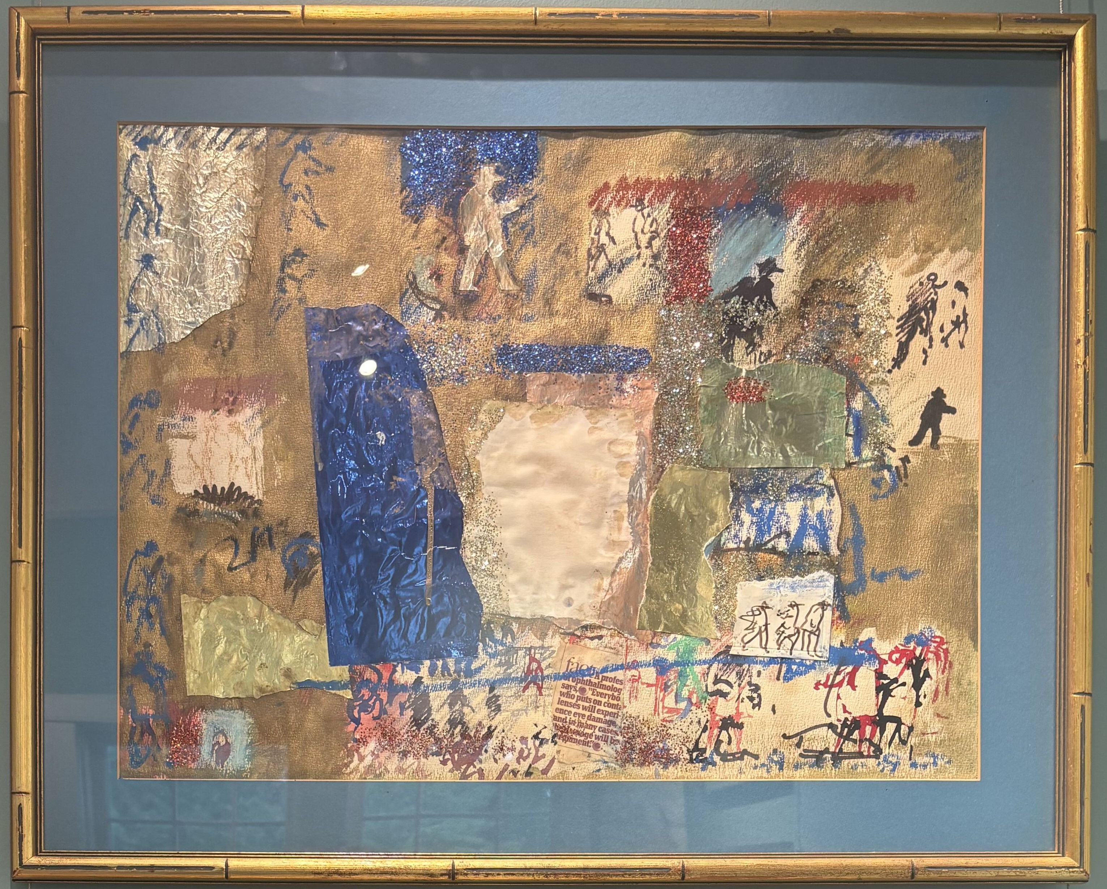
Untitled Figured – Collage, 1990

Don Kommit
24 in x 18 in
Acrylic, Ink, Colored and Metallic Papers Collage

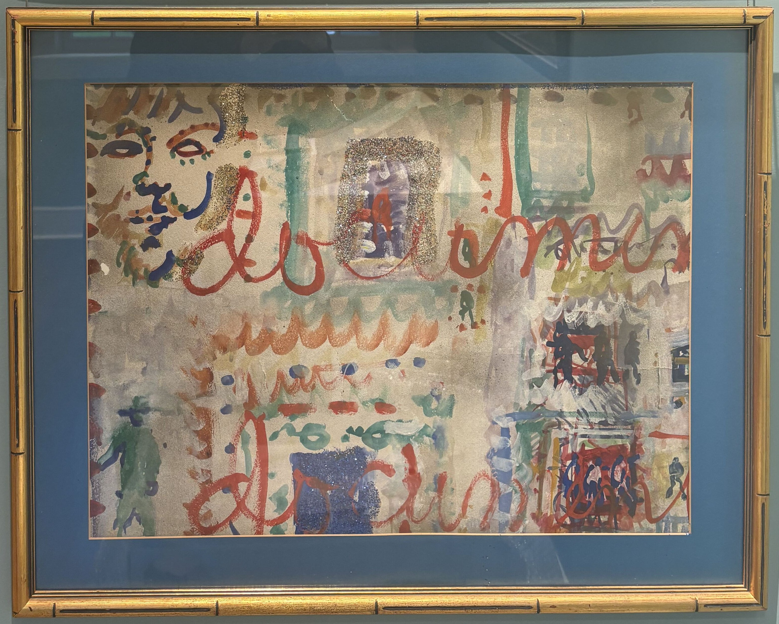
Documes Collage, 1990

Don Kommit
24 in x 18 in
Collage, Acrylic on Heavy Watercolor Paper

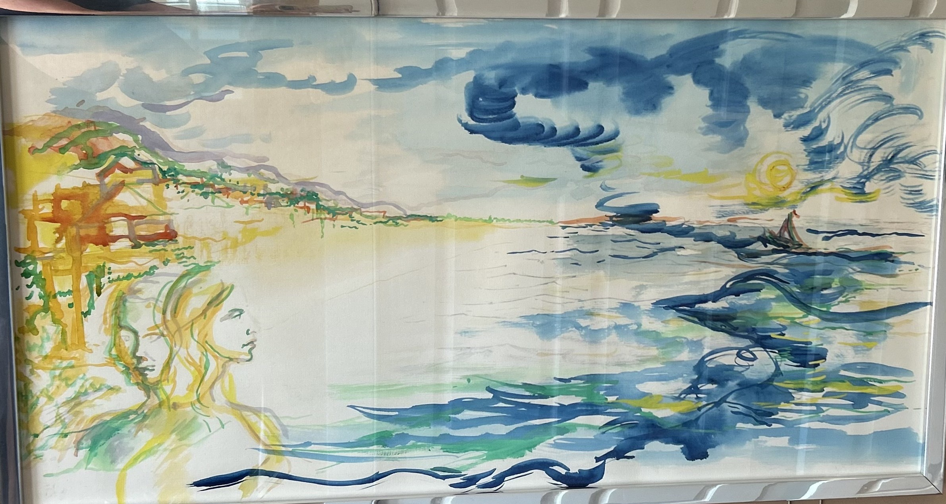
Dream Sunset Seascape, 1990

Don Kommit
36 in x 19 in
Acrylic on Canvas

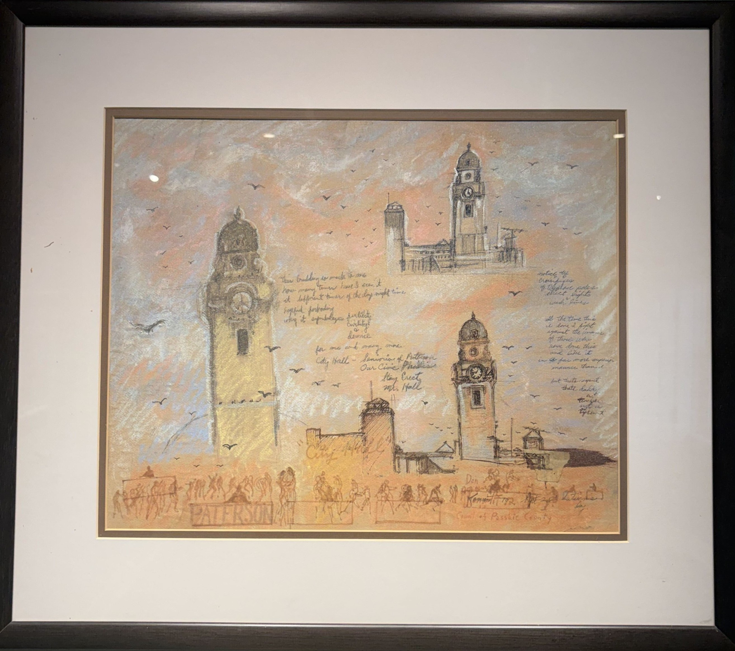
Three-Views of Paterson City Hall,
1978

Don Kommit
24 in x 21 in
Pastel, Pencil, And Sepia Marker on Greytone Paper

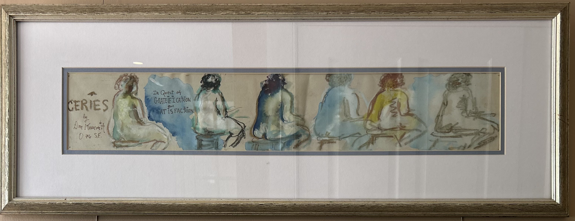
Ceries, 1976

Don Kommit
34 in x 21 in
Ink, Pastel on Watercolor Paper

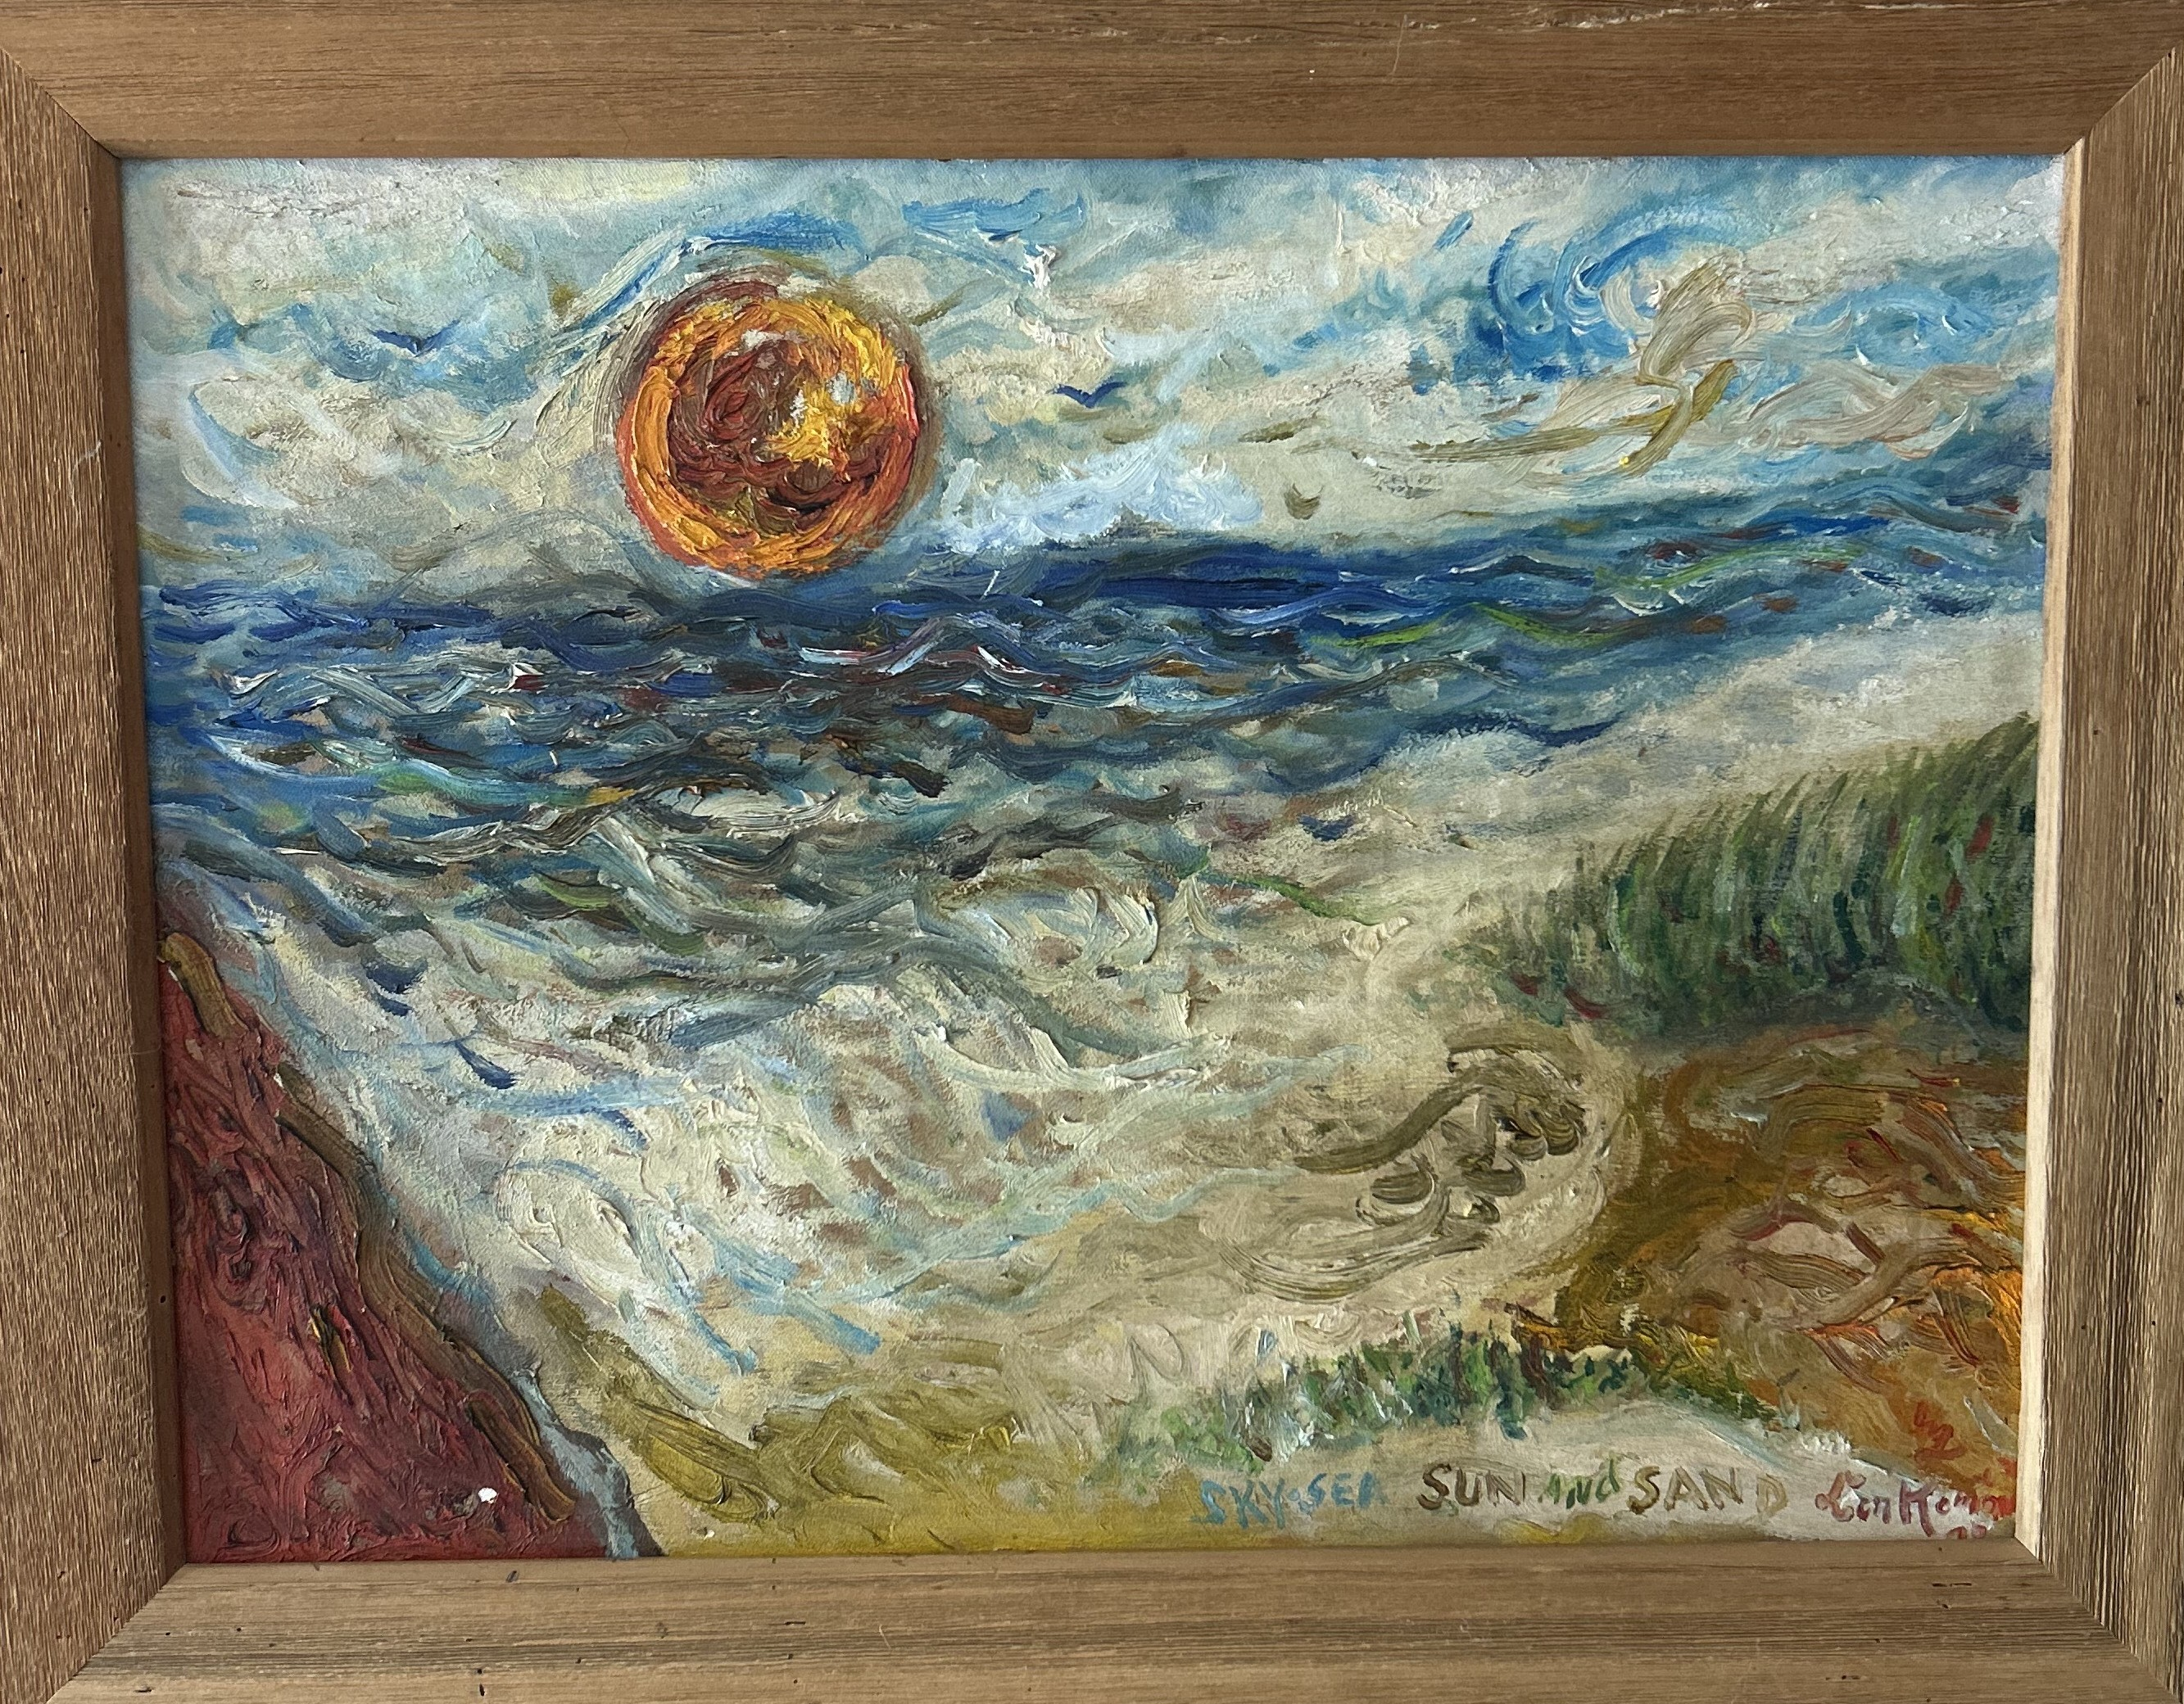
Sun, Sea, Sky, Sand, 1978

Don Kommit
28 in x 22 in
Acrylic on Canvas

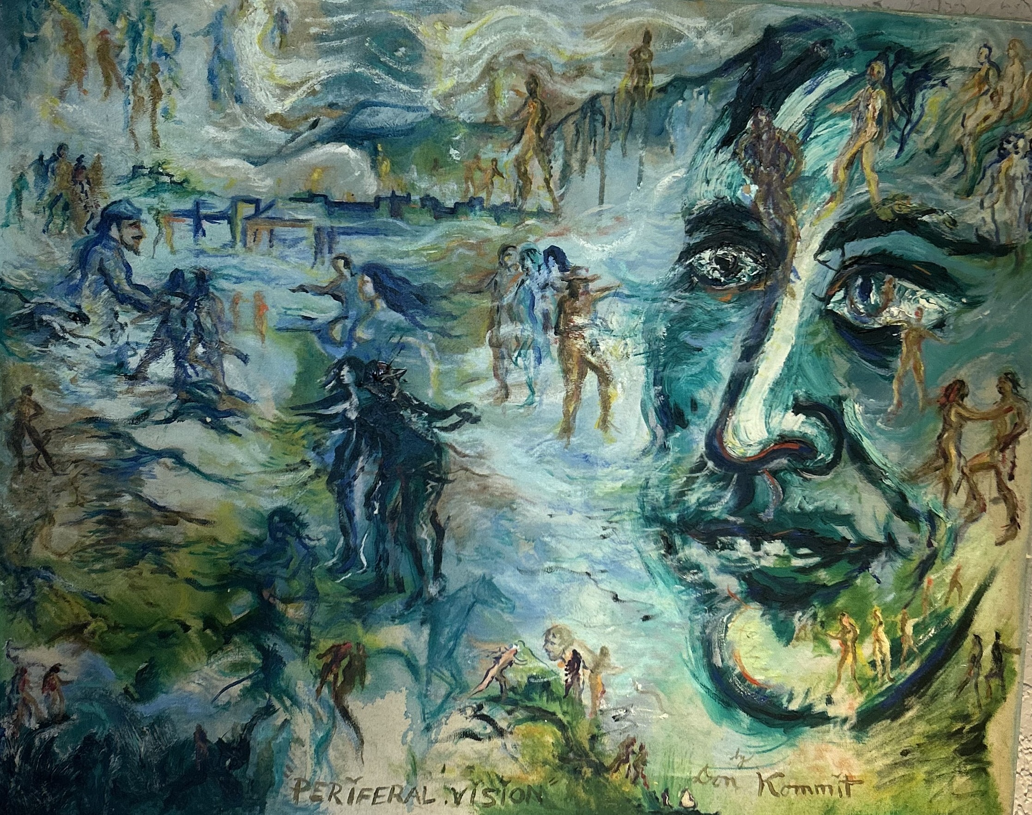
Periferal Vision, 1978

Don Kommit
30 in x 24 in
Acrylic on Stretched Canvas

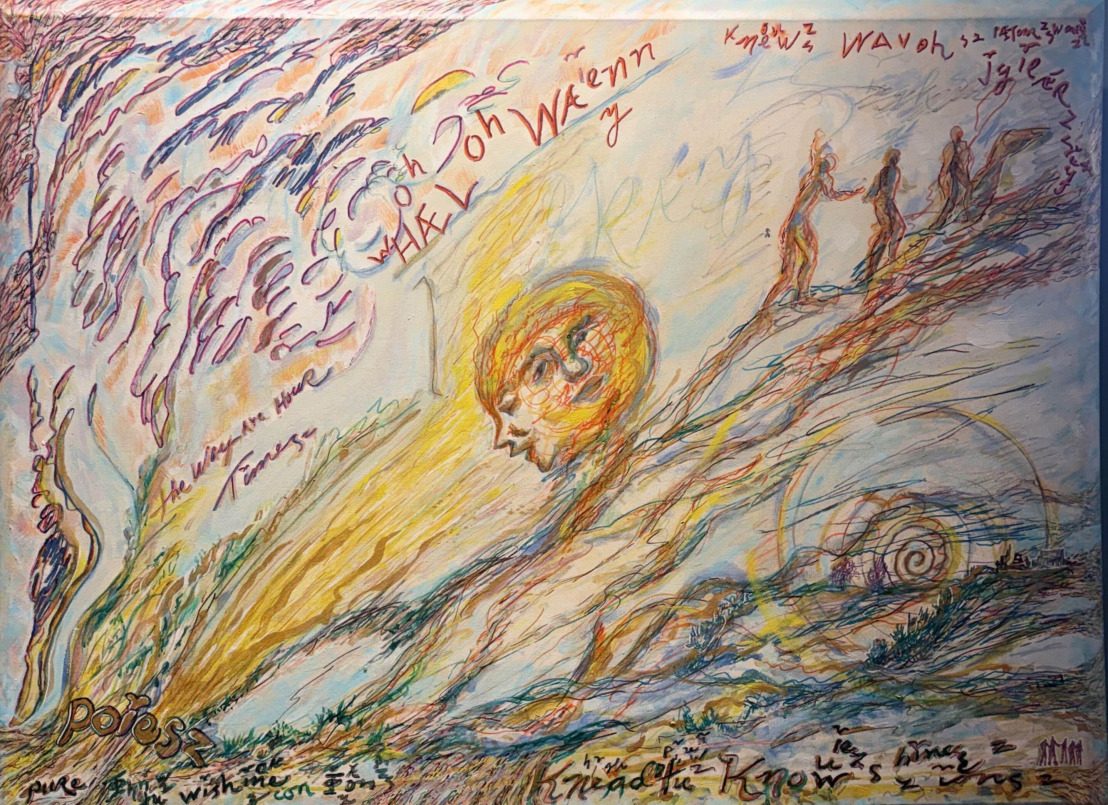
Hael on Walnn, 1990
Don Kommit
40 in x 30 in
Acrylic on Canvas

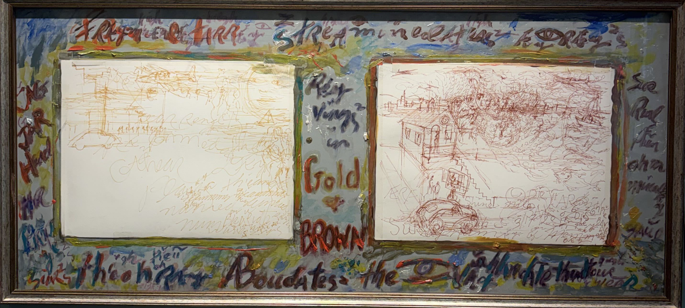
Gold & Brown, 1980

Don Kommit
30 in x 16 in
Ochre Gold and Sepia Markers, Paper,
on Painted Chipboard

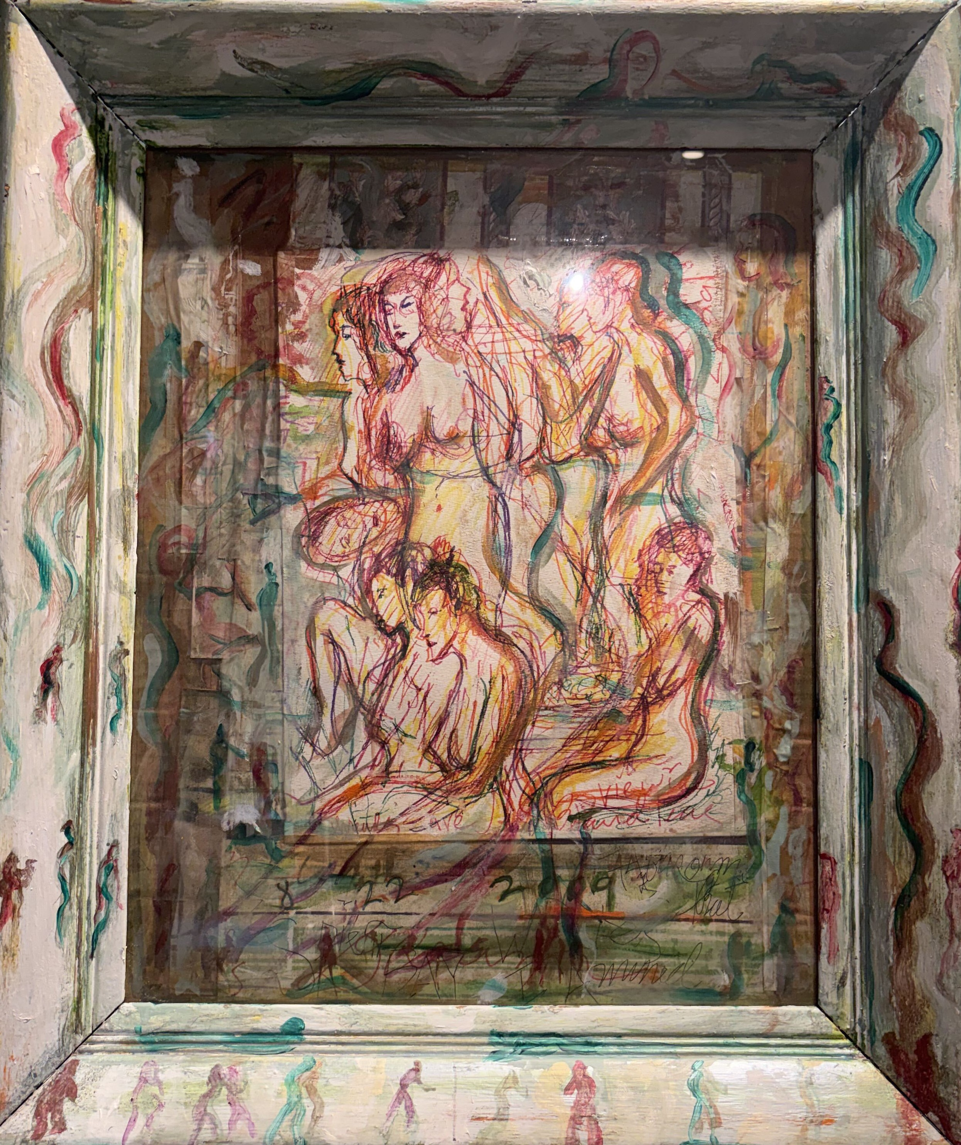
Women in a Pale Green Frame, 2009

Don Kommit
16 in x 20 in
Pen Drawings, Watercolor, Collage, on Carboard

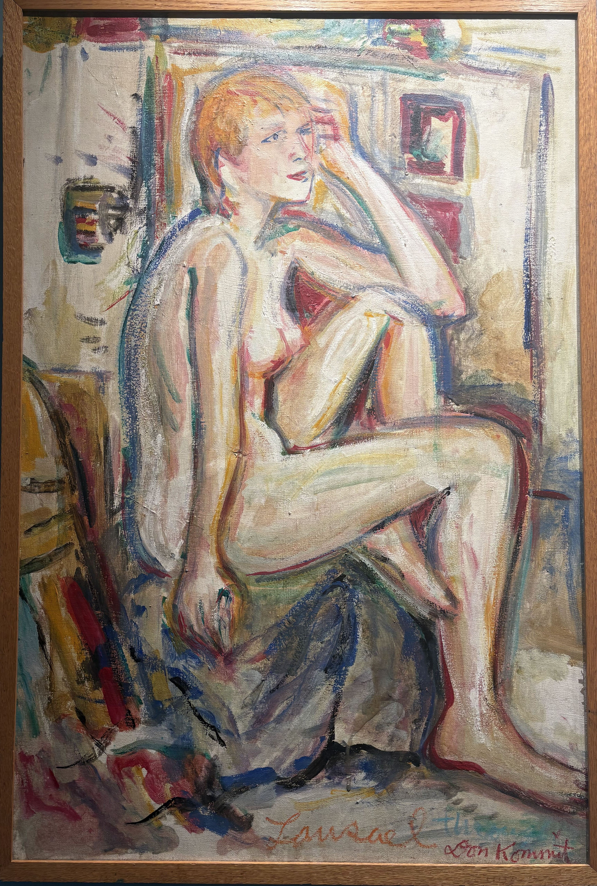
Lousael, 1980

Don Kommit
36 in x 24 in
Acrylic on Canvas

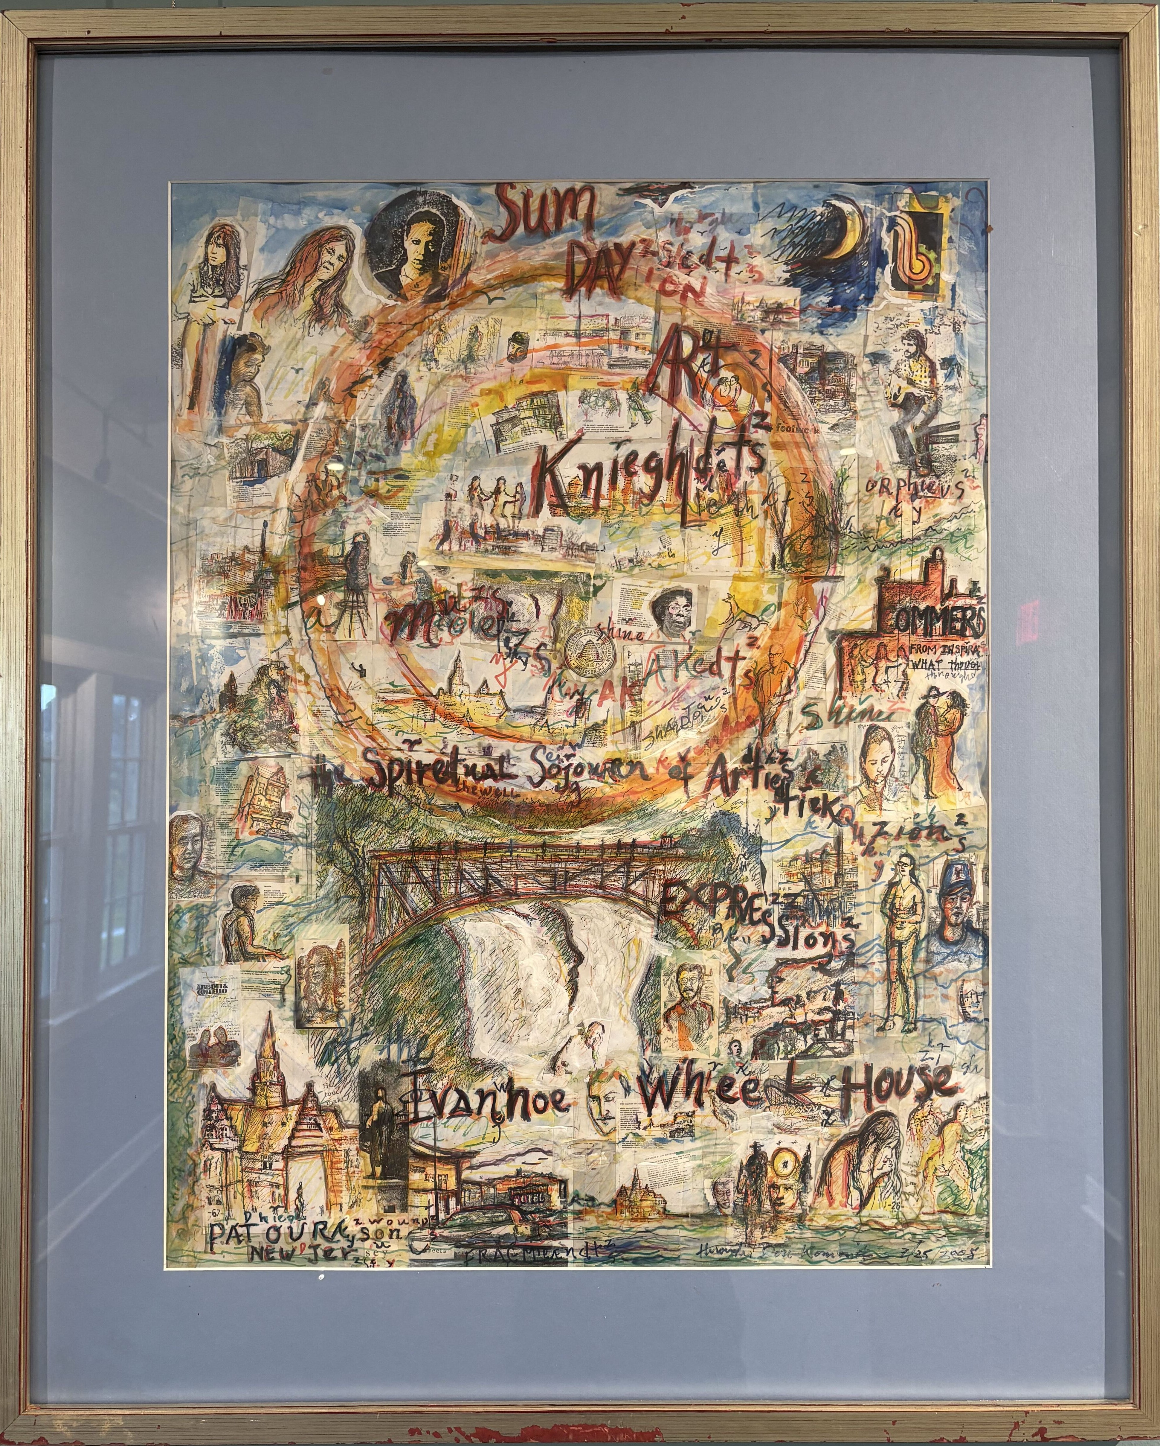
Sunday Art Nights at the Ivanhoe
Wheelhouse, 2005

Don Kommit
18 in x 24 in
Markers, Collage on Paper

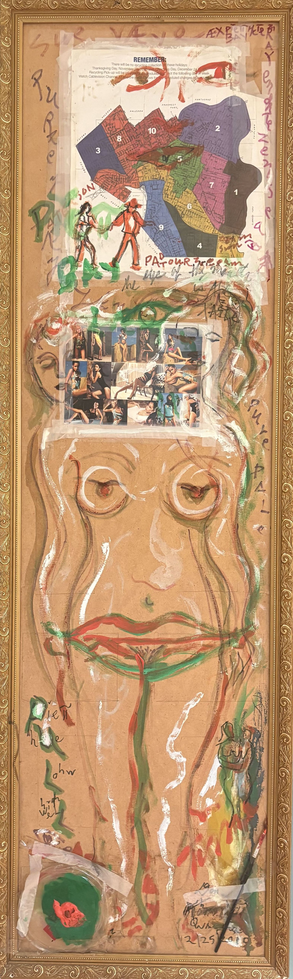
Bikini, 2019

Don Kommit
48 in x 13 in
Acrylic, Collage, on Painted Chipboard

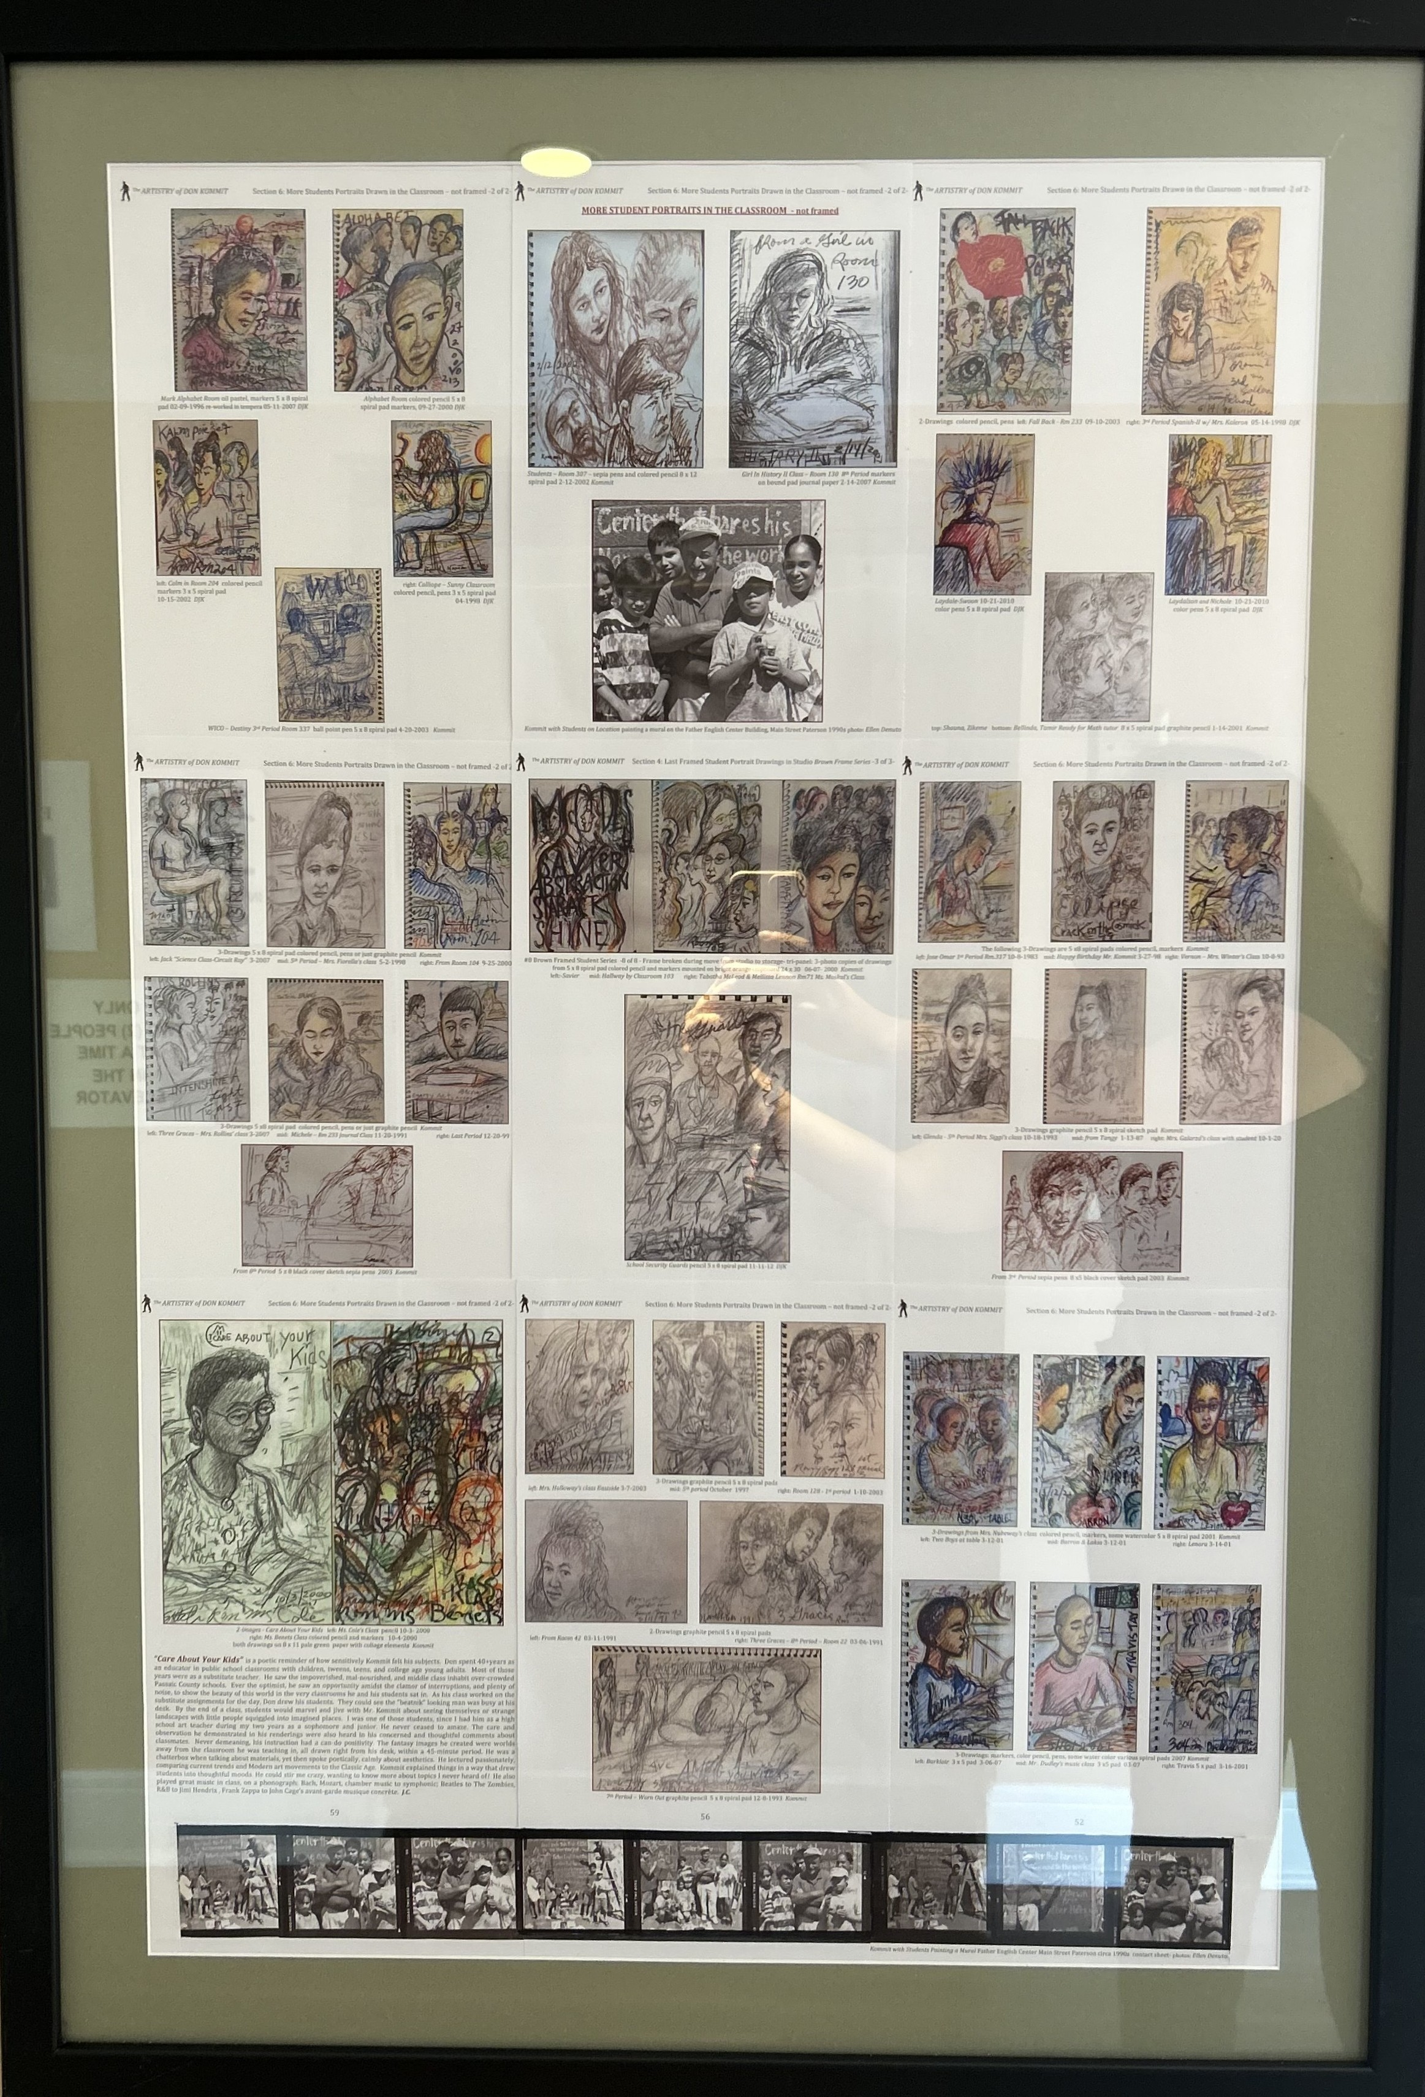
Student Portrait Series, 2025

Don Kommit
40 in x 28 in
Drawings on Paper

Artist Statement:
Early works:
Don Kommit’s executive functioning was a laser-focused work ethic, ever inquisitive, drawing every day of his life. This paid off in spades with portraits, shifting from realistic renderings to whimsical. Don captured the likeness of a face, with an accent on its uniqueness, quickly, and effortlessly. He could summon an exact touch, working with a jeweler’s precision. Precise is what seems to be operating through DJ’s seemingly imprecise methods. He conjured images through searching lines, following an invisible thread of “the now.” He stitched or sketched, as he would remind me, just as a tailor fashions pieces of cloth into a garment. Don’s images stitch rhythmic marks and reinforce accents into dynamic shifts of many colors. He also knew the art of dressing. As seen in the photo on the right, he was never without a jacket. He had a fabulous collection of ties stuffed into two dresser drawers. He never seemed to wear the same one, twice.
Abstract:
Once a drawing implement was in hand, Don was interested in capturing something before him or something he could not explain, nor define, yet only conjure. It was difficult for Kommit to end up with a non-objective result, for he was rooted in a Surreal and Fantasy aesthetic, ever exploring fanciful narratives. Watercolor was his medium of choice when composing an abstraction. Pencils, pens and markers were too inclined to veer him toward representing known portraits, places, and poems. Pens are synonymous with writing words and, since Don was always wordsmithing his images, his lines would shift from the contour of a form to phrases, and back again, while seamlessly changing colors or mediums. Don may have seemed to be in a “world of his own” while drawing, yet the places he was adventuring to in his imagination were all about capturing the place he was in and people he was surrounded by.

Surrealism:
Kommit blurs the line between Fantasy and Surrealism. He was the embodiment of both idioms, as seen in this section. A Dalí disciple, Don’s aesthetic was Dadaist merging wordplay into fanciful images. Salvador Dalí transformed realism into surrealism, using the tenant of the absurd as his magic wand. Don mastered realism only as it pertained to portraits, often with stunning accuracy, mirroring his sense of the absurd. Kommit’s surrealism merged semiotics* with writing that runs through so many of his drawings. Don would often start writing a phrase, or just letters that trailed off into images. Doors and walls were not out of bounds for Don’s musings.
Futurism:
Don’s drawing is an excellent example of Futurism, the early 20th Century Idiom of Modern Art, 1850-1950. Futurismo forms the foundation of Dada in the 1920s, then Surrealism in the 1930s. Commencing in Italy, the movement portrayed the dynamism of industrialism. Dynamism is an idiom of Futurism using fragmented forms, vibrant color and motion-based techniques in painting and sculpture. The worldwide impact of speed from the advent of trains in the mid-1800s, leading to planes, then automobiles contributed to the formation of Futurism, with an aesthetic focused on the energy at which urban life was affected by such mobilization. With the impact of electricity and its manifestations in machinery, then communication: telegraphy, to phones, kinescope to cinema, and you can see how artists like Kommit continued to be fascinated by artists like Umberto Boccioni, 1882-1916, a principal Futurist.

Artist Biography
By Joesph Coco as seen in The Artistry of Don Kommit
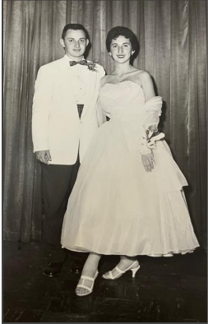
Kommit’s aesthetic was as devoted to Humanist ideals as he was to Modernist movements. He revered the arts of antiquity and could discuss Greek philosophy in his sleep. His William Paterson and Rutgers University training prepared him well to the cannon of Western Art. The Renaissance particularly resonated with him. He was an unfathomable scholar. I attest to this, having separated over 2,000 published books of all disciplines mixed in with 1,549 of his sketchbooks! Having been to Italy twice, he infused his life with Italian café culture, finding the kind of camaraderie and subjects to build an impressive oeuvre. Don’s hometown of Paterson was a substitute for Florence. The Comet Don Kommit blazed through Passaic County. This is the first book to present his artistry through the many themes he explored, in context with the Contemporary Period he came of age in, 1950 -75, and the Post-Modern Period, 1975 - 2000, in which he matured. Future writers, art and social historians will have the pleasure of discovering his place in time, through ground he explored throughout his career, which began in 1956 while in the marines through his last twenty-two years into the 21st Century.
DJ’s tendency was playful. Whimsy lent itself to the Fantasy, Dada, and Surrealist idioms illustrating Kommit’s playful tendency. Developed in the 1920s, they are still alive and well today, especially prevalent in graphic / cinema arts. Notice how Don stretches figures, attenuates physiques. This Mannerist influence can be seen above in the late Renaissance artist Parmigianino’s painting “Madonna with the Long Neck.” Examples of his elongating faces are seen in the portraits of Tabetha McLeod and Melissa Lennon and Mecca. -left and right in this paragraph- Don understood how this shifted his tendency to capture a likeness toward Expressionism or looser representation. The Ash-Can artists of the Expressionist 1920s and 30s placed their subjects in dark urban tone settings. Kommit displays Paterson Street life in bright luminous colors, never depressing a scene. His inner-city student portraits, drawn in the classrooms he taught, throb with life: intimate, inquisitive, inventive.

El Greco 1541-1614 is another example of Mannerism seen on the left. In this detail from the painting “The Burial of Count Orgaz” (1586), El Greco mannered or elongated his figures, interpreting the heavenly realm Count Orgaz was entering. This early Baroque style helped artists navigate religious themes into a more ‘modern’ approach, pre-dating Surrealism by 350 years. The thin figures of Kommit’s Women – Green Frame, at right, is Don’s way of alluding to an ethereal place. The women seem to be dancing in a spiritual realm, not just an earthly room. El Greco depicts the light of the heavens, making the clothes appear transparent, as if a spiritual light is entering through them, making the figures appear translucent. Light is not simply spotlighting the scene but emanating. Don does the same, using the white of his drawing paper to infuse the light of the room as if light is shining from the figures. Depicting the figures naked is Kommit’s way of eliminating artifice, getting to the heart of humans as divine. Don well understood that the classical Greek artists were all about infusing their earthly figures to match the divinity of the Gods and Goddesses. This artful philosophical connection pre-dates Renaissance Humanism by 2,000 years
A third example of Mannerist technique is the large oil on canvas entitled “The Last Supper,” 1592-94. Here Tintoretto, 1518-1594, shows two dimensions using lamp light in the room to merge mystical figures (floating in that light) at the precise moment Jesus is blessing bread and wine. This communion is at the heart of a Christian mass, allowing the participant to take in the spirit of Christ. I am sure that filmmaker Stephen Spielberg has been influenced by Tintoretto’s masterpiece, (a detail seen at left). In the first Indiana Jones film, when the Arc Of The Covenant is opened, spirits fly through the room. Don’s way of showing that spirits share the same space that humans do, that spirit life moves freely through the world, is drawn with searching lines, agitating the surface, showing multi-dimensions. In Kommit’s “Three-Graces,” body, mind, spirit, are depicted multi-dimensionally in one portrait, portraying the essence of humankind
Paterson was a backdrop for Kommit’s way of expressing the joy he saw in his city’s version of the American melting pot. Under his watch, drawings and poems simmered, amused and delighted, expressing the multi-cultural potpourri he experienced. Don did not complain about urban blight or pollution; rather, he focused on the dynamism around him. Kommit was a walking Wikipedia® of Paterson history. While with him on errand runs, which included a requisite stop to any one of his many favorite cafés, a walking history tour was included: the architecture, the businesses they housed, the many Gaetano Federici’s statues, mills, unions, or images of America’s Founding Fathers, who organized the nation’s first industrial complex, “The Society of Useful Manufacturers” - S.U.M. If you see the word “Paterson” in his drawings and poetry, you will see his clever word play, spelling it as “Pater-SUM” as well as “Pater-swoon.” Perpetually finding two ways to use a word, you can see how Don tips his hat to those Founders. His enthusiasm swoons over Paterson’s Great Falls, the raceways powering the many train and textile mills, Hinchliffe Stadium, and John Holland’s submarines launched in the Passaic River, etc. Kommit would be the first to exclaim that “the Passaic” was America’s first polluted river, then wryly add, the first river in America to be cleaned up in the 1970s. Paterson and the mighty Passaic River were Don’s muses, his playground. Don rode his VW Bug like a chariot. While perusing this book, notice how often the “magic bug” appears in his drawings.

Ever operating under a beleaguered budget, the Paterson Museum manages to present Passaic County’s Capital, preserving its storied history. Considering its hampered assets, the Museum presents educational exhibits, fine art shows, and poetry events. Ever since Catholina Lambert* sold much of his Impressionist Collection in the 1920s, that art became the stars of The Metropolitan Museum’s modern wing. Since then, Paterson has always drifted behind in cultural prestige, as Paterson’s industrial might shifted after WW-II globalization. The famous people most associated with Paterson overshadow the city’s luminaries: Alexander Hamilton, sculptor Gaetano Federici, poet Allen Ginsburg, comedian Lou Costello, baseball’s Larry Dolby. Perhaps it is time to add Kommit to the Pantheon. Leaving 1,549 sketchbooks, -approximately 125,000 drawings rendered in them- is likely a Guinness World Record. Consider his 50+ year legacy as an educator - 1963 through 2013. He has overseen approximately 20,000 students, in large part because he spent 40 years as a substitute teacher, typically with students for one day or one week. After perusing Kommit’s sketchbooks during 2021 through 25, I assess there are 20,000 images of students drawn directly from the classrooms he presided over. Most of these are immigrant children making Paterson their home and the United States their nation. Such is Don’s gift to Paterson and the world. J.C.

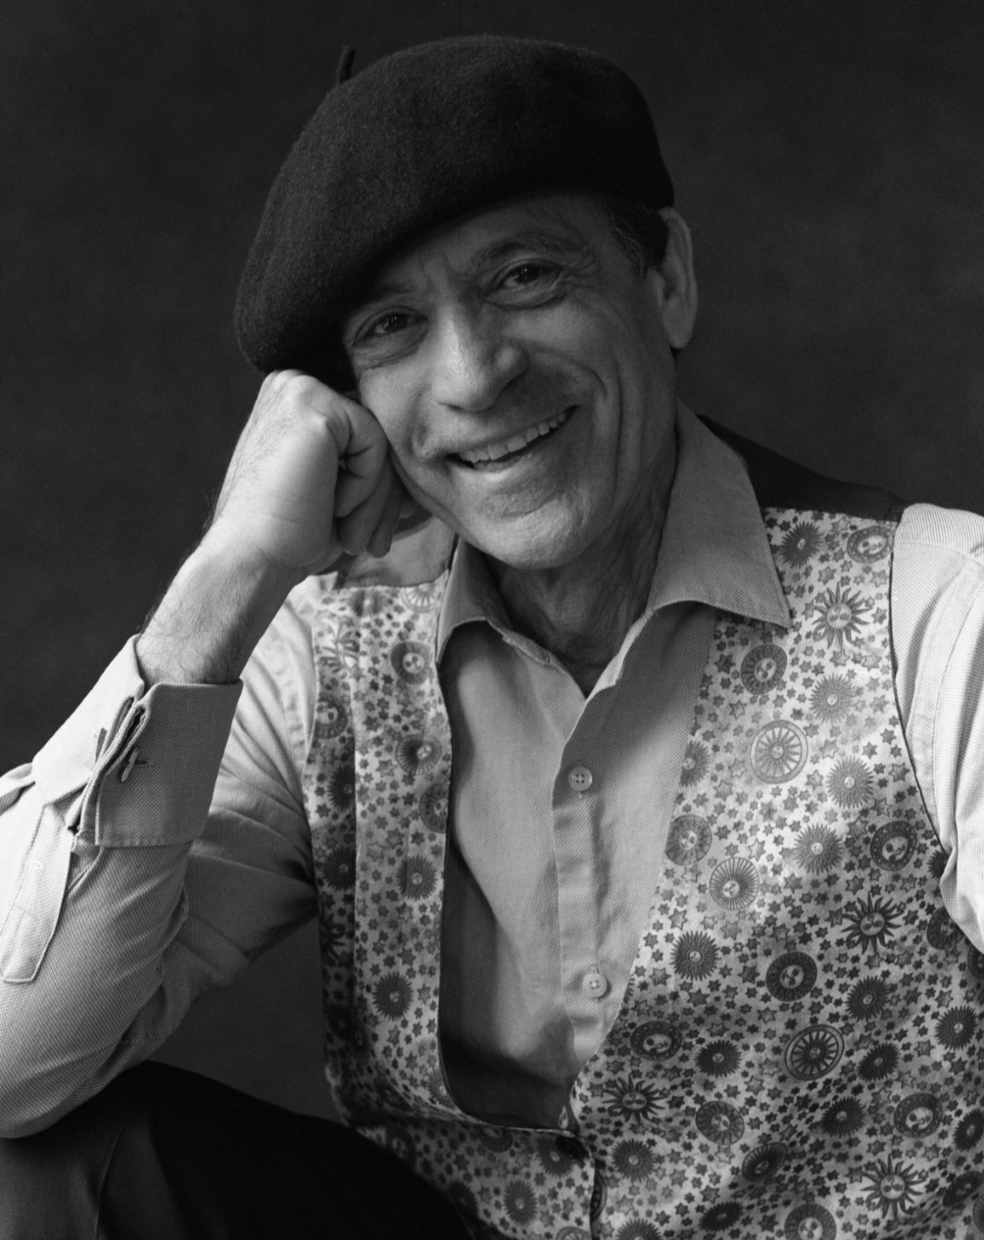
Biography of Joesph Coco,
Steward of Don Kommit Estate

Driven by an insatiable desire to depict his dreams, Coco also works from nature, en plein-air. Art instruction commenced in Passaic High School with mentor Paterson luminary Don Kommit. Training with Carlos Villa at the San Francisco Art institute helped orient Coco’s innate propensity toward narrative fantasy. During his formative years, music and songwriting meshed with creating soundtracks for various painting and drawing series. An interest in naturalism and symbolism came together in Coco’s Master of Fine Arts degree, Rutgers University, New Jersey, in 1986. His thesis on synesthesia, the inter-relationships and collateral sensations within color and sound, brought him together with renowned professors Leon Golub / Painter-Social Realism, and the pioneer Performance and Computer artist, Rafael Montanez Ortiz.
Coco majored in Anthropology during his first semester of college at Northern Arizona University, Flagstaff. Such initial interests in world culture and archeology led to understanding that mythology and archetypal themes suited his fledging abilities as an artist / musician. Re-grouping to an art major at the San Francisco Art Institute for three semesters, by1973 Coco returned to Flagstaff. Studying under the direction of John Davidson, and Bruce Horn, he received a Bachelor of Fine Arts degree from Northern Arizona University in 1974. Coco produced eight one-man exhibitions through 1980. By the time he left the Northland, he was performing regionally, producing his first album Never Satisfied, which brought him to Warner Bros in NYC. The influence of his studio partners of five years, photographers John and Helen Running, Michael Collier, and artist-designer Luis Tomas, gave him an appreciation for Native American and Mexican culture, deepening his expanding interests in mythology and color symbolism, with a drive to depict his surroundings through landscape themes.
Such influences seen in Coco’s expansive Paterson Great Falls series Sound Image - Falls River reveal his interest in synesthesia, the correlations within sound and color. Coco combined his original instrumental music composed for this painting and drawing series into videos using the very first desktop Mac and PC computers in1984. This includes the series Solar Eclipse and A Nuclear Holocaust, which toured the United States in over three dozen solo exhibitions, and twenty invitational shows, such as the United Nations “Exhibition for A Nuclear Free Society.” These early digital works were reissued in 2010 into a box set entitled, “The RE-Mastered -DVD- Collection– 3-Videos and Film.” This special edition of 50 entered Museum and Library Special Collections in the United States and Europe. These include California’s MOMA-SF, DeYoung, S.F. Art Institute, and L.A. County museums. New York’s Whitney, Guggenheim, Queens. Pennsylvania’s Philadelphia-MFA, Allentown, and Michener; Boston’s-BMA and Institute of Contemporary Art; Chicago’s Video Bank and Museum of Contemporary Art; New Jersey’s Newark, Zimmerli, Princeton, Lambert Castle and Paterson Museums, Ohio’s Rock n Roll Hall of Fame, Japan’s Hiroshima Peace Memorial, Lisbon’s Gulbenkian, and Rome’s-Nazionale Contemporanio.
The Last Full Moon series started in 1972. 136 paintings, drawings, and prints were celebrated with a 50th Anniversary string of 16-monthly installation exhibitions at Centenary University throughout 2022-25. Coco is the “first artist to create the most extensive series on the moon; unprecedented, unequaled in the history of World Art.” (quote from Art Historian - Alessandra Onuf / Ph.D.) Each painting starts in December on the day the full moon rises, as a synopsis of Coco’s year. January moon images anticipate the year ahead. This autobiographical approach includes his fascination with astronomy, astrology, geography, current events, and archetypal forms, and mythological subjects. I Paint The Moon is a 270-page color book was released in 2023. Published by Luminarios Press and Flying Game Press.
Coco was the Assistant Project Director and Press Agent for the first International Symposium of ART and Invisible Reality. Working with Rafael Montanez Ortiz, they produced exhibitions and site-specific sculptures during a 7-day conference, with 74-artists, performance artists, native culture practitioners, scientists, psychologists, and psychics during October 1989. Panel discussions were held at Franklyn Furnace in New York City and Rutgers Galleries in New Jersey.
If Walls Could Speak, “redefines the image of Sicily.” The series includes two books of short stories, paintings, drawings, and photographs, as well as eleven albums compiled during Coco’s 5-year residence in Sicily and Portugal. Volume One: IF WALLS COULD SPEAK - The Black & Blue Ink Series 82-stories, and Volume Two: UNDISCOVERED COUNTRY -The Sepia Ink Series 103-stories. Coco’s 4th International exhibit of the series took place in the summer of 2006 in Geraci, Sicily, the village where his grandparents immigrated to America in 1910. The exhibition premiered in December 1996 in Teatro Vittorio Emanuele, Messina, Sicily. This exhibit of 106 paintings and drawings filled five galleries in Italy’s second largest opera house. A double album of music composed for the series, released in 1996, includes Silver Lamp, 13-instrumentals, and Sicilia, 19-selections inspired by Sicily from albums recorded between 1994 through 2009
Foliage has been an ongoing series for over thirty years. Capturing light on the surface of short-lived blossoms, Foliage started in Flagstaff, Arizona in 1975. Concentrating on certain times of day, and differing blossoming trees, paintings are often worked in diptych formats, or in triptych sets as large as 66 x 42 canvases. 1982s Foliage season saw an installation of 9-canvases in 3-vertical blossom sets at 9’6 x 42, debuted in Rockefeller Plaza’s Time Warner building in 1982. NYC’s Bon Wit Teller exhibited this large triptych at their 57th Street store in 1984. Centenary University recently exhibited the series in 2022 and 2024. Forty canvases shown in the spring of 2025 at Brig O’doon Gallery, Ottsville, PA, were followed up with “Summer” and “Autumn” images from the series at Luminary Gallery Coffee House, Lambertville, N.J. into the second half of 2025.
Over 450 paintings, drawings, prints, of Coco’s are collected in over 375 public and private collections. With 112 solo shows in America and Europe, he has exhibited in over 95 competitive and collective shows since 1970. European museums include Coco in their collections: Lisbon’s Gulbenkian; Rome’s- Gallaria Nazionale Di Contemporaneo; and Kridel Securities – Paris. Between 2013 throughout 2025, Coco has exhibited various series from his oeuvre with Centenary University’s Taylor Memorial Library Gallery and the Nadar Group Gallery, both in Hackettstown, New Jersey.
Currently, Professor Coco is teaching at Centenary University in New Jersey. Centenary’s Taylor Memorial Library gallery has hosted 18 exhibitions by the artist of six series from his career. This includes the entire FULL MOON SERIES presented in 8 installations. An exhibit of Kommit’s paintings and sketchbooks, featured during the spring semester of 2026 celebrates the release of this book The Artistry of Don Kommit.
Coco has taught at eight other colleges and universities since 1989 including Delaware Valley University, Doylestown, PA 2008 – 2016 and Montclair State University, NJ, 1999 - 2020. Coco’s capabilities are the wealth of an inspired, visionary, tenacious talent.

